ANWAR
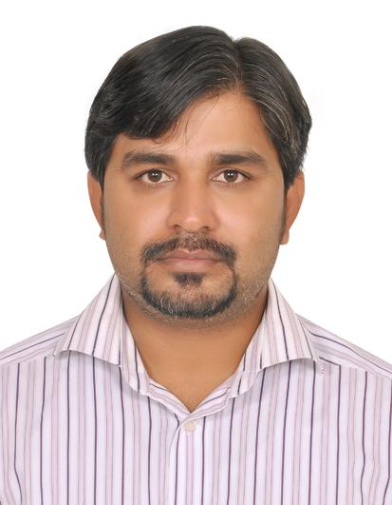
ANWAR.337740@2freemail.com

OBJECTIVE:
To obtain a challenging position in a progressive organization with an aim to contribute positively towards the organization’s goals and objectives and do excel in the dynamic and fiercely competitive arena of management.

ACADEMIC QUALIFICATION:
Matriculation from Sindh Board of Technical Education in Technical Science Group in the year 2003-04
Appear in Diploma in Electrical

COMPUTER SKILL
MS office Word, Excel and Power point
Internet
ETC

WORKING EXPERIENCE:

NIFT (National Institutional Facilitation Technology
Worked as a Data Control Officer. 08 dec2003 to 05 Nov 2007

N.N Power engineering & service.
Worked as a Assistant Electrician 01 July 2008 to 30 Aug 2010

Bank Islami Pakistan LTD
Worked as a Rider 01 Aug 2009 to 30 Sep 2010

Express Logistic Courier Service
Worked as a Rider 01Oct 2010 to Till Date

McDonalds Pakistan
Worked as a Rider & Kitchen Staff.(Part Time) 2012 to 2013

PERSONAL PROFILE:

Date of Birth: 16th April 1988
Religion: Islam (Sunni)
Marital Status: Single
Nationality: Pakistani

LANGUAGES:

Urdu
English

REFERENCE:
Will be furnished upon request

