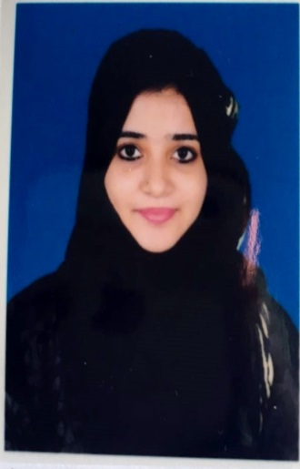 CURRICULAM VITAE
ZAKIYA
ZAKIYA.337741@2freemail.com
PERSONAL INFORMATION:
Date of Birth: 27/08/1994
Sex: Female
Marital Status: Married
Nationality: Indian
Current address: DEIRA, DUBAI
VISA STATUS: VISIT VISA
VISA EXPIRY: 15/04/2017
PROFILE:
FRESHER

CAREER OBJECTIVE:
To work, create a team-oriented environment, perform and win the appreciation of my co-workers and leadership. To excel in industry and achieve highest level along with the growth of the organization.
ACADEMIC DETAILS:
COMPLETED BCA
Institution: Al-Ameen Institute of Information Sciences
Year of Passing: JULY 2015
Percentage: 62%
TECHNICAL SKILLS:
- Knowledge in programming languages like C, Networking , Visual Programming language, HTML.
- Hands on knowledge in Microsoft Office Tools.
- Creating Data Base Tables, Edit and Manipulate. SQL(Structured Query Language, Oracle 8i & Oracle 10g)
PROJECT EXPERIENCE:
Project 1: “ Mobile Store Management”
Project Summary Highlights:
- Easy access to the data.
- User interactive.
- Very informative.
- Keeps track of customers and their comforts.
Technologies Used: Visual Basic, Oracle Database.
Project 2: “Crime Management System”
Project Summary Highlights:
- Reduces time consumption on the paper process.
- Making data management easy for the FIR process.
- Easy to use since it uses the graphical user interface.
- Keeps track of users comfort.
Technologies Used: ASP.Net, SQL Server R2.
STRENTH:
- Very patient and dedicated to achieve my goals.
- Very good at improving my language.
- Independent and decisive.
- Very good imaginative and strategic thinker.
- Ability to listen attentively.
- Honest and Direct.
LANGUAGES KNOWN:
English
Level: Fluent in speaking and listening, competent in reading and writing.
Hindi
Level: Fluent in speaking and listening, competent in reading and writing.
Urdu
Level: Fluent in speaking and listening.
DECLARATION:

I hereby declare that the above said particulars are true and correct to the best of my knowledge.

