AREAS OF EXPERTISE

Query resolution
Customer service
Handling complaints
Up selling
IT skills
Office administration
PERSONAL SKILLS

Excellent telephone manner
Assertive
Listening
Confident

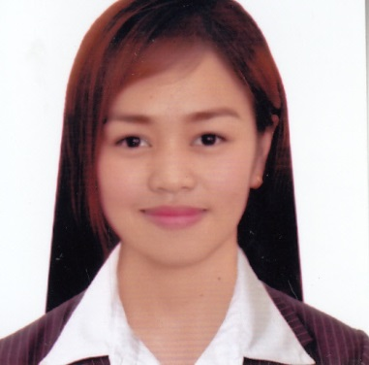

KIMBEL
KIMBEL.337748@2freemail.com
PERSONAL SUMMARY

A highly motivated, confident individual with exceptional multi-tasking capabilities and able to work in a target driven, busy cell center environment. Hardworking with excellent attendance and punctuality records who can work equally well alone or as part of a team. Can communicate effectively with people from diverse backgrounds and would be an asset to any employer who respects loyalty and responsibility.
Keen to find a challenging position within an ambitious employer where I will be able to continue to increase my work experience & develop my abilities.
Sales Agent Representative
IConneq Experts Solution
2/F RGI Bldg., Bued, Calasiao, Pangasinan
December 7, 2015 – December 15, 2016

- Tasked with answering projecting a professional company image through phone interaction with new and existing clients. Main duties include answering customer enquiries, resolving their problems, up selling & making appointments for engineers.
- Involved in processing orders, forms and applications.
- Accurately recording details of calls and issues on logging software.
- Identifying and escalating priority issues or customer complaints.
- Sending emails to clients answering their enquiries.
- Taking ownership on all calls and queries answered.
- Arranging appointments for engineers to attend premises & make repairs.
Customer Service Associate
Convergys Baguio
Ordonio Dr., Camp John Hay, Baguio, Benguet 2600
March 5, 2014 – December 4, 2015

- Making sure that all telephone calls are answered promptly.

ACADEMIC QUALIFICATIONS

Tertiary Education
Bachelor of Science in Information Technology
2010 – 2014
University of Pangasinan-Phinma Education Network
Arellano St., Dagupan City, 2400

High School Education
2006 – 2010
Virgen Milagrosa University Foundation St. Dominic Highschool
Martin P. Posadas Ave., San Carlos City, Pangasinan. 2420

Elementary Education
2000 – 2006
Central II Elementary School
Roxas Blvd., San Carlos City, Pangasinan, 2420

- Following up customers by calling them back.
- Sending emails to clients answering their enquiries.
- Accurately recording details of calls and issues on logging software.
- Having a professional and courteous manner at all times.
- Identifying and escalating priority issues or customer complaints.
- Arranging appointments for engineers to attend premises & make repairs.
- Essentially receiving up to 50 incoming calls from customers daily.
- Providing advice, information and assistance to callers.
- Attempting to resolve all enquires on first contact with the caller.
- Dealing with customer’s queries, requests, orders or complaints.
- Accurately recording details of calls and issues on logging software.
- Having a professional and courteous manner at all times.
- Identifying and escalating priority issues or customer complaints.
KEY SKILLS AND COMPETENCIES

- Able to handle complex calls and situations.
- Demonstrating empathy and understanding when talking to customers.
- Able to deal with irate, abusive and irate callers.
- A proven track record of handling high volume calls.
- Can type up to 30 wpm.
- Excellent listening and problem solving skills.
- Excellent communication skills and telephone manner.
- Good keyboard skills and knowledge of customer service principles & practices.

