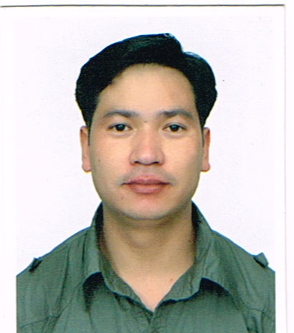

Resume

sukuram

sukuram.337750@2freemail.com

CAREER OBJECTIVE:

A dedicated team player, intend to build a career with a team of committed and dedicated people to achieve the highest level of proficiency in the job which will help me to explore myself and realize my potential to seek for a position that will lead me to utilize my knowledge based on my previous experiences by putting my creative and innovative for the development and the expansion of your reputed firm.
KEY SKILLS:

- Capable of working with minimum supervision and willing to take extra responsibilities.
- Ability to work with an attitude of hard work.
- Highly presentable with the customers.
- Confident of holding responsibilities towards given assignments.
- Can participate and interact with people from different nationalities.
- Ability to work on own initiatives making strong interpersonal with self discipline.
- Capable to multi types of work.

JOB PROFILE:

A high motivated, flexible, enthusiastic and adaptable with challenging environment and capable of working with a minimum supervision, a part of team possessing normal education background.

WORK EXPERIENCE:

- Working as a sales/stocker at MAF Carrefour hyper market in Dubai.
- Worked as a sales/stocker at Al azizia Panda United Co. (Kingdom of Saudi Arabia) “Hyper Panda” from 19th August 2008 to 20 august 2012. In electronic and F & B section under FMCG..
- Worked as a salesman in electronics parts section at seven star impex in Nepal from 2 feb.2002 to 4 feb.2003
- Worked as a sales executive in auto spare parts section at malhotra enterprises in Nepal from jan.2004 to may 2008.
- Worked as a House keeping at MARSYANGDI MANDALA GUESTHOUSE in Nepal 2nd feb.2013 to 2nd feb 2014.

TRAINING:

- Computer training from Kathmandu Nepal ms-office, ms-words, ms-excel, ms-power point, windows multimedia, virus scan, email, internet etc.
- Food safety and hygiene training delivered by RMK-the experts FZ LLC. UAE Dubai Knowledge Village.
- Nepal police training from metropolitan police commissioner’s Kathmandu Nepal
- Mobile Repair Training from CTEVT (Council for Technical Education and Vocational Training) Nepal.

ACADEMIC QUALIFICATION:

- SLC (School Leaving Certificate) Government Board of Nepal in 2000 AD.
- PCL (Proficiency Certificate Level) equivalent of +2 from Tribhuvan University of Nepal in 2004 AD.
PERSONAL DETAILS:

Date of Birth : 25th Dec. 1981
Sex : Male
Marital Status : Married
Nationality : Nepali
Religion : Buddhism
Spoken Language : Fluent in English, Hindi, Nepali, Basic Arabic.
Visa expiry date : 21/03/2017
Notice Period : 2 weeks
Character Reference:
I hereby declare that all the data stated above are the supported with the legal documents. Many Thanks.

