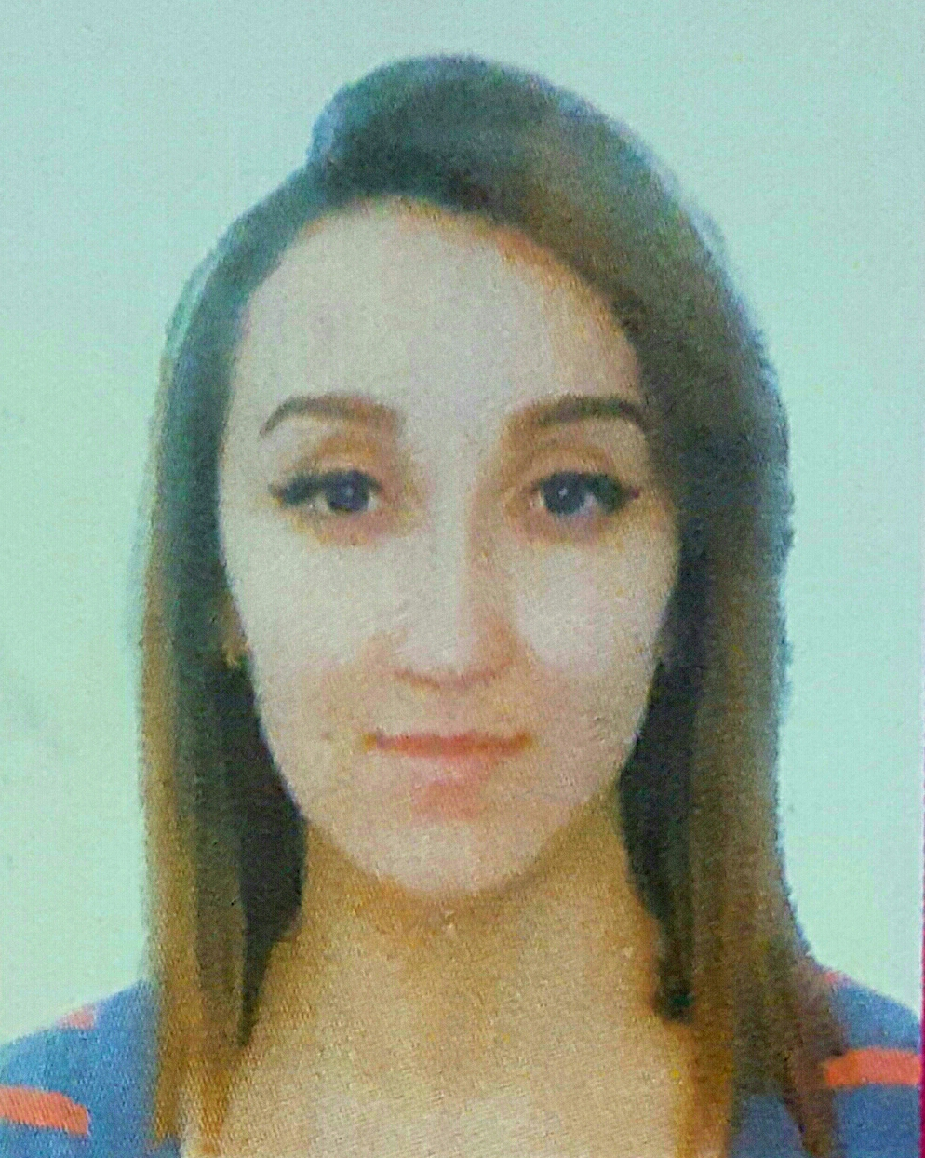

**ATROUNE**

Age : 23

Adresse : Haizer centre, Bouira.

Bouira-Algeria

[**ATROUNE.337768@2freemail.com**](mailto:ATROUNE.337768@2freemail.com)

**FORMATIONS**

**2010-2011 Baccalauréat in economy**

***Bouira – Algeria*** High school of Amzil mhamed

**2013-2014 Finance lisense**

***Bouira – Algeria*** University of Akli Mohand olhadj

**2012 4 semesters of Marketing**

***Bouira - Algeria*** International institut of Management INSIM

***Langues :* English : Good.**

**Frensh: excellent.**

**Arabe: excellent.**

***Computer skills :*** Basic macrosoft word, excel, power point, outlook.

***2012-2013 -* Hostess -LINDT.**

**- Commercial prospector– FORD AUTO MOBILE.**

***Octobre 2013 -*  Sales consultant – MUST SARL FASHION BEAUTY STORE Bouira. Algeria**

***Février 2015* - Responsible for shift -MUST SARL FASHION BEAUTY STORE Bouira.Algeria**

**Achieved tasks**:

- Management and systhematique contrôle team.

- Admenistrative tasks (mail respond, meeting organisations, preparing daily reports).

- Marchandising.

***Aout 2015-2016* - Intérim of responsible store- MUST SARL FASHION BEAUTY STORE.Bouira.**

**Achieve tasks**:

- Respond to the requirement of the direction SARL Fashion Beauty Store.

- maintaining the development of the Store.

* serious, dynamic, responsible.
* Ability to work under pressure.
* Hard working, flexible, relaible and intention to details.

**PROFESSIONNEL EXPERIENCES**

**PERSONNELS CHARACTERISTIC**