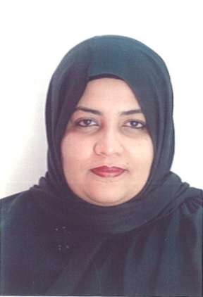
Amina
Amina.337779@2freemail.com

HAAD Licensed Pharmacist

Personal Summary

A motivated pharmacist with a real passion for healthcare and the ability to develop and grow a pharmacy business. Experienced in maintaining administrative records such as pharmacy files/patient profiles and in providing excellent customer care by accurately dispensing prescribed medications by calculating, weighing, measuring, and mixing ingredients. Able to advise patients on medication brands, medication storage, medical equipment and health care supplies.
Currently looking for a suitable pharmacist vacancy in a modern well equipped pharmacy.

Work Experience:

- Pharmacist
Universal Hospital – Abu Dhabi LLC
From August 29th 2015 to August 31st 2016
- Pharmacist
Alsanhoory Modern Pharmacy
Jan 2007 – Feb 2012

- Pharmacist
National Fund Military
July 13, 2005 – Dec 12, 2006

Duties and Responsibilities:

- Accurately dispensing drugs to patients according to a doctor’s prescription.
- Checking prescription for errors and making sure they are appropriate for patients.
- Measuring, packaging, labeling and recording medications issued to patients.
- Instructing patients on how to use medications, possible side effects and storage.
- Contacting and working closely with other healthcare professionals.
- Answering questions from patients and staff about medicines.
- Ensuring the accuracy of all prescriptions, products and services supplied.
- Helping to develop the pharmacy’s electronic discharge system.
- Managing and resolving complaints.
- Talking to regular patients to see how their treatment is going
- Able to trains and supervise Pharmacy Assistants.
- Communicating with customers sympathetically and supportively.
- Giving private consultations when required.
- Maintaining pharmaceutical stock, creating inventories and ordering more drugs.

Key Skills and Competencies.

- Keeping up to date developments in the pharmaceutical industry.
- Experience of providing medicines management support to GP practices.
- Experience of participating in clinical pharmaceutical research.
- Able to provide quality face to face customer interaction.

Areas of Expertise:

- Dispensing medication
- Clinical expertise
- Commercial awareness
- Administration
- Health promotion
- Customer service
- Management of medicines

Professional

- HAAD License
- Registered Sudan Medical Council

Training Certificates:

- Wafrapharma Laboratories (on the Job Training)

Academic Qualifications:

- Bachelor of Pharmacy in University of Khartoum
Dec 31, 2003

