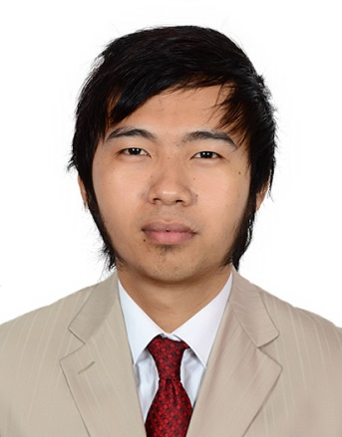
ISRAEL
ISRAEL.337789@2freemail.com

POSITION DESIRED: SAFETY OFFICER

Career Objective:
In the capacity of safety officer, I foresee myself as an effective contributor to any organization in its endeavor to safety and success. I possess the interest, capacity and motivation to play an effective role in the organization I work for.

Accreditation:
- PHILIPPINE SOCIETY OF SAFETY PROFESSIONAL (MEMBER) ABU DHABI U.A.E

Additional Certificates:
- Bonified Member of PSSP (PHILIPPINE SOCIETY OF SAFETY PROFESSIONAL) Abu Dhabi U.A.E
- Environmental Health & Safety Essential Course (EHSEC) Abu Dhabi U.A.E
- Hazard Identification and Risk Assessment Abu Dhabi U.A.E
- Firewarden Certificate Abu Dhabi U.A.E
- IOSH Managing Safely Course Abu Dhabi U.A.E
- NEBOSH (IGC) Abu Dhabi U.A.E

Trainings Attended:
- Hazardous Substance
- Basic Incident Investigation and Reporting Awareness
- Bosh Awareness
- Basic Working at Heights
- Basic Risk Assessment Awareness
- Basic Excavation Safety
- Electrical Safety
- Safe workplace, tools and equipment awareness
- Basic fire safety awareness
- Traffic management and safety
- Manual Handling

Duties and Responsibilities:
- Conduct first day at work safety orientation to all newly hired employees/workers 4 hours a week.
- Conduct daily safety toolbox meeting to all project workers prior to start of work.
- Conduct daily toolbox talk prior to start of the shift.
- Administer the preparation and monitoring of work permits prior to start of operations as required by the client.
- Ensure that all firefighting equipment are in excellent condition at all times.
- Provide advice and counsel to all employees regarding compliance with site safety requirements of the project.
- Supervise the preparation of various safety signs and installation of safety barricades as required inside the worksite.
- Make frequent and unscheduled inspection of work in progress and report hazards of unsafe practices related to the HSE Supervisor/ HSE Engineer.
- Maintain prescribed records and ensure posting of notices or signs related to safety.
- Prevent working staffs from taking unnecessary risks.
- Give special concern to housekeeping and ensure that the site is maintained cleaned and tidy.
- Ensure that safety precautions are rigorously applied in terms of equipment procedures and job content.
- Assist and planning or conducting safety meetings.

Additional Training Attended:
Accreditation:
- THE GLOBAL PINOY ACADEMY (TGP)

COURSE:
- AUTOCAD 2D BASIC
- AUTOCAD 2D INTERMEDIATE

SCOPE OF TRAINING
- Researched with the engineering and designing team to draft design specifications and create concept designs accordingly.
- Design 2D and 3D illustrations from the technical specifications and architectural plans as per the sketches approved by engineering team.
- Revised existing product designs to include advanced features.

Experienced Details:

D & Y Safety Services and Quality
Simlong, Batangas City, Philippines
Position: Structural Fabricator
Inclusive Date: December 2011- January 2013
Duties and Responsibilities:
- Align and fit parts according to specifications using jacks, turnbuckles, wedges drift pins, pry bars and hammers.
- Lay out and examine metal stock or workpieces to be processed in order to ensure that specifications are met.

Gulf Piping Company
Mussafah, Abu Dhabi, U.A.E
Position: Structural Fabricator
Inclusive Date: February 2013- December 2016

Duties and Responsibilities
- Move parts into position, manually or by using hoist or cranes.
- Mark reference points onto floors or face blocks and transpose them to workpieces using measuring devices, squares, chalk, and soapstone.

Educational Background:

SECONDARY: Banaba West National High School
SY: 20O7-2008 (GRADUATED)

PRIMARY: Sta. Rita Elementary School
SY: 2002-2003 (GRADUATED)

Personal Information:

Age: 25 years old
Weight: 58 kgs.
Height: 5’6
Birth Date: October 18, 1991
Status: Single
Citizenship: Filipino
Religion: Born Again Christian

I hereby certify that the information above is true and correct to the best of my knowledge and belief.

