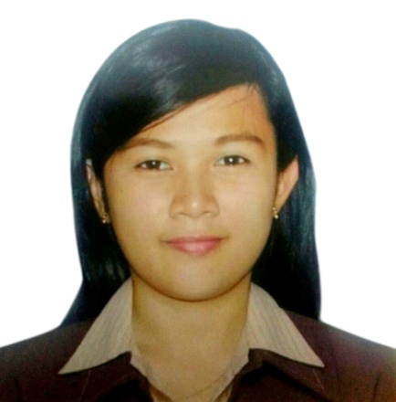
KIMBERLEE
KIMBERLEE.337793@2freemail.com

OBJECTIVE

- To be a part and asset of a highly recommended and competitive company.
- To be able to work with others while obtaining knowledge and understanding the work environment.

COMPETITIVENES

- Has sufficient knowledge in hospitality, tourism and in food and beverages.
- Service oriented and
- With comprehensive knowledge in Microsoft OPERA and ABACUS, Microsoft Word, Excel and PowerPoint.
- Can easily adapt to a different culture.
- Capability to work well under pressure.

EDUCATIONAL BACKGROUND

Colegio San Juan de Letran Bachelor of Science in Hospitality Management
151 Muralla St.,Intramuros June 2009 - March 2013
Manila, Philippines

Pateros Catholic School Intermediate Level
P. Morcilla St., Pateros June 2005 - March 2009
Metro Manila, Philippines

PRACTICUM

Restaurant Practicum:
- Hardrock Café, Washington DC
999 E St. NW Washington DC 20004
Server / Busser
March 10, 2012 to June 17, 2012

In- House Practicum
- Knights Café, Colegio San Juan de Letran
Kitchen Staff / Server
400 hours
July 2012 – November 2012

- Page 1620, Colegio San Juan de Letran
Barista
100 hours
November 12, 2013 – January 7, 2013

WORK EXPERIENCE

AL AIN ROTANA
Zayed Bin Sultan St. Al Ain Abu Dhabi, United Arab Emirates
Waitress
May 2014- May 2015

EDSA SHANGRI-LA HOTEL
1 Garden Way Ortigas Center, Mandaluyong City, Manila Philippines
Food and Beverage Attendant
Banquet Server / Butler / Receptionist
August 2013 – March 2014

HARDROCK CAFÉ- MAKATI
Glorietta III, Ayala Avenue, Makati City Philippines
Host
April 2013 – July 2013

TRAINING & SEMINARS ATTENDED

- Safety of Life at Sea (SOLAS)
Basic Safety Training Course
Magsaysay Training Center, Ermita Manila
February 11-17, 2013

- Butler Service
Pan Pacific Manila
February 2, 2013

- SOAR: Enhancing Knowledge Through Developing Trends in Hospitality Profession
Colegio San Juan de Letran, Manila
February 2013

- Micros Opera Property Management System (Micros Fidelio Software Philippines)
Colegio San Juan de Letran, Intramuros, Manila
March 15, 2012

- Basic Butchery and Fish Mongery
Magsaysay Institute of Hospitality & Culinary Arts (MIHCA)
July 9, 2010

- Discover Ilocos Tour
January 17-21, 2010

- Exploring the World of Unexplored
Colegio San Juan de Letran, Manila
September 2009

PERSONAL INFORMATION

Birthday: October 1, 1992
Civil Status: Married
Nationality: Filipino
Height: 5’4”
Weigh : 65kg
Language: Fluent in Filipino and English, beginner in Spanish
Religion: Roman Catholic

