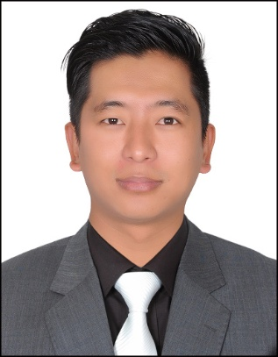
YANGDEEP
YANGDEEP.337905@2freemail.com
CAREER OBJECTIVE:
Believing that customer satisfaction is my service, I would like to obtain a customer service position your company with my full dedication and sincerity at work by providing customer centric service which would in turn lead to progress of the establishment.
KEY FEATURES:
- Through understanding and experience of customer service concepts.
- Enjoy working in a team.
- Ability to relate courteously with customers from all different backgrounds.
- Excellent communication skills.
- Supervising coordinating and motivating staff in all aspects of BPO operation and services.
- Ensure that orders are actually prepared and delivered timely to customers.
- Ensure that customer’s issues are handled accurately, efficiently and in complaints with company policies and producers.
- Work in close coordinating with management to ensure that newly hired associates receive orientation training.
PREVIOUS EMPLOYMENT
BIG BAZAR –SALES ASSISTANT – 2011 – 2012
DUTIES AND RESPONSIBILITIES:
- Welcome and advise customers (so practice with smiling).
- Ensure goods are well displayed (an organized shop is a happy shop).
- Handle payments.(both cash and card)
- Arrange ordering and delivery.
- Receive deliveries from suppliers.
- Keep the shop floor clean and tidy.
TELLIS CALL CENTRE: Call Supervisor at tech support -2012-2015.
DUTIES AND RESPONSIBILITIES:
- Takes orders by obtaining and verifying information.
- Enters orders by transmitting information.
- Provides product/service information by answering questions; offering assistance.
- Maintains call center database by entering and verifying information; updating contact log.
- Improves quality results by recommending changes.
- Keeps equipment operational by following established procedures; reporting malfunctions.
- Updates job knowledge by participating in educational opportunities.
- Enhances organization reputation by accepting ownership for accomplishing new and different requests; exploring opportunities to add value to job accomplishments
EDUCATIONAL BACKGROUND
- Passed Madhayamik Parkisha examination (10+) from saint Alphonsus Higher Secondary School. (29th May 2007)
- Passed higher secondary examination(12+) (14th JAN 2009)
From St.Alphonsus Higher Secondary School
- Pursuing graduation from St. Xavier’s College.
EXTRA QUALIFICATION
- Diploma in computer Application (D.C.A) from Sterlite Foundation.
- Participant in National Cadet Corps
PERSONATIONAL INFORMATION
- Date of birth :05th of April 1991
- Nationality :Indian
- Marital status : Single
- Languages Known :English , Nepali ,Hindi
VISA STSTUS: visit visa

