LAKSHMANAN
Lakshmanan.337908@2freemail.com

Planning & SCM Professional

--------------------------------------------------------------------------- --------------------------------------------------------------------------------
Career Summary
A Seasoned Engineering & Management Professional with over 20 years of global exposure in handling Planning, Supply Chain & Customer Engagement Functions
Core Competencies
Strategic Planning ~ Demand Planning ~ Logistics ~ Multi-Site Operations ~ Cost Control ~ Budgeting & Forecasting ~ Trend Analysis ~ Production Control ~ Procurement ~ Inventory Control ~ Process Redesigning ~ ERP Implementation ~ Customer Engagement
Educational Qualification

Bachelor of Engineering – Mechanical
June 1993 | 1st Class with Honours
Graduated from Sardar Patel College of Engineering affiliated to University of Mumbai
PGDBA– Operations Management
June 1996 | Distinction & Batch Topper
Graduated from Welingkar Institute of Management – A premier management institution in India

Professional Experience
European Perfume Works Co LLC | May 2005 – till date | Location – Sharjah, UAE
Executive Assistant to CEO (from 1/10/15 till date)
Assist CEO in :
-All operational process improvement projects in supply chain .
-Service Level improvements
-Inventory reduction measures
Senior Manager – Planning & Supply Chain (from 5/5/2005 – 30/9/2015)
(A 300 Million AED Scion Group Company Headquartered in UAE involved in manufacturing of Perfumes , Colour Cosmetics, Aerosols, & Personal care products with a Global presence in the brand name of Jean Paul Dupont (JPD) , Creation Lamis , Parfum Oriane, Doral Collection , Paris Collection , Cheri Paris Trendies )

Role Brief:
As a Head – Planning & SCM, I am responsible to deliver over 900 SKU products & engagement across 70 countries with optimum utilisation of Funds, Materials, People and Time in co-ordination with Sales, Purchase, Production, Quality, R&D, Logistics and Warehousing.

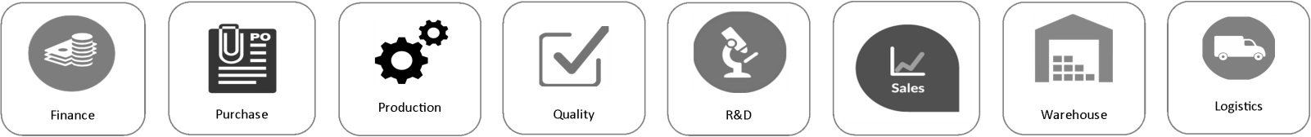
Stakeholders
Job Responsibilities

Planning & Forecasting
- Plan & Device Frame work for AOP and periodic review and realigning due to Sales or Operational Issues
- Capacity planning based on the forecasts for the UAE & India Factories
- Planning & Analysis of Sales Estimation & Demand forecasting across geographies based on Seasonal and Historical demand trends.
- Long Term & Short Term Material and Resource Management for seamless and optimum Production
- Effective utilisation of Working capital through constant coordination with all Stake holders.
- Monitoring Resource cost, Material cost& expenditure on monthly basis in order to have control over Business Operation
- Constantly work on lead time reduction to improve efficiency in Order- to- Cash cycle.
Customer Engagement, SCM & Logistics
- Key contributor on Organization’s objective of “Customer Delight” through constant interaction with the stake holders of all Group Companies spread across the 70 countries & complete Customer Engagement Process on Query Management, Region Specific Documentation & Complaint Resolution
- Periodic Product Rationalization & Active items through MIS analysis.
- Managing the entire Supply Chain & Logistics of India & UAE factories cut across Production, Warehouse, and Direct Exports & Sales spoke location for 700 Sku’s across 70 countries spanning 4 continents.
- Headed the implementations of Sales & Distribution ERP module JD Edwards Version 9.1
- Headed the migration & Implementation of Demand Planning module from Internal ERP to JD Edwards 9.1

Balsara Group of Companies | June 1996 – April 2005 | Location - Mumbai
Logistics
Senior Manager – Planning
(Currently a DABUR group company involved in manufacturing oral care products, insect repellents, air fresheners and household cleaners having manufacturing facility in 5 location in India in the brand name of Babool , Meswak , Odomos , Odopic , Sanifresh , Odonil etc)

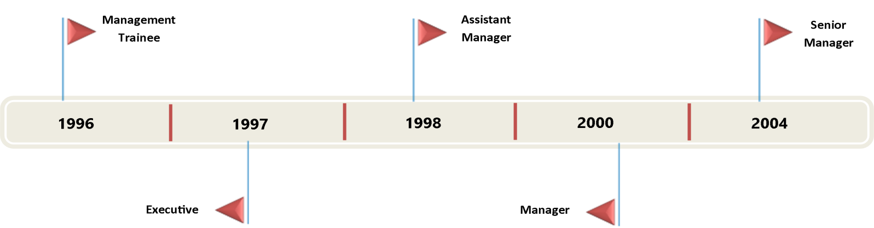
Growth Path

Role Brief:
As a head of Planning Department was responsible for Complete Production Planning, Raw Material Procurement Activity of in-house manufactured products, Outsourced products and Third Party Contract Manufacturing Vendors of Balsara to ensure 100+ Service Levels to our Growth Centres.
Production Planning
- In charge of Complete Production Planning Activity of in-house manufactured products and Third Party Contract Manufacturing Vendors of Balsara to ensure 100+ Service Levels to our Growth Centers.
- Coordination with Internal Customer Teams like Domestic Sales , International Sales , Neighboring Countries Sales and Institutional Sales and ensure their fullest satisfaction in servicing their requirements
- Coordination with Purchase Team, R&D Team, Packaging Development Team, Factory Operations and Finance Team so that the above objective is met.
- Responsible for the Production Planning and Raw Material Procurement of in-house perfume manufactured for select products.
- Vendor development and negotiations as ongoing projects in case of outsourced products and In-house Perfume Raw Materials.
- Was a PTL in MM and SD modules of SAP 4.6 C.
Annual Budgeting & Capacity Planning
- Preparing Materials Budget involving procurement cost, volume budgets and overheads budgeting.
- Initiating budgetary control on procurement and production costs.
- Computing Optimal Finished Goods sourcing costs based on cost matrix model.
- Creating monthly unit wise production plan based on Net Sales Requirement, Production Capacity of units, Guidelines of optimal finished goods sourcing calculations done while annual budgeting, releasing production plan to manufacturing centres with specific date targets.
3rd Party Manufacturing (for outsourced products)
- Managing complete 3rd Party operations of scouring products and certain export products.
- Key activities includes Production Planning , Costing and Quality Audits coordination
Ion Exchange India Ltd | June 1993 – January 1994 | Location - Mumbai
Logistics
Trainee Field Engineer – Projects Division
- Handled the independent task of Erection & Commissioning of 6 Major Water Treatment Plants across India
Personal Details

D.O.B : 23.08.1971
Gender : Male
Nationality : Indian
Visa Status : UAE Resident Visa
Driving Licence : Holds a valid UAE Driving Licence
Marital Status : Married

