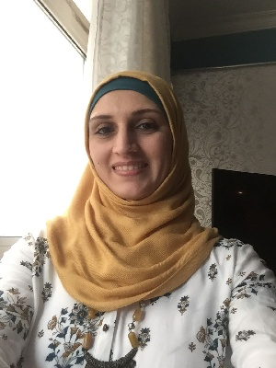
CURRICULUM VITAE of SAMARA
E-mail: SAMARA.338018@2freemail.com
Nationality: Jordanian
Languages: English and Arabic.
Material status: Married/ Mother for 3 Childs.
Visa Status: Valid Residence Visa, Dubai.

Objective: To Join to the Teacher’s crew as Math Teacher, to utilize my Academic study experience and extensive knowledge & experience of American Mathematics Curriculum for Grades 1st- 6th.
Passionately committed to student development and establishing productive learning environments, Possess sterling reputation for designing fun, educational, and enriching lessons and activities that inspire and motivate children. Adept at customizing approach to drive academic success.

Experience: 4th, 5th & 6th Grade Math Teacher / Private / 2014-Present:

Taught students with multiple modalities using appropriate method and according to the school curriculum. Motivated students utilizing learning techniques for individualized and small group instruction, maintained books, instructional aids, and supplies, and created progress report, developed weekly lesson and participated in district level curriculum programs.

Private lesson:
Taught students ARABIC, ARABIC for NON SPEAKERS, SIENCE and Islamic.

Accountant / Highpoint FZE/2013-Present:

Preparing accounts and P&L sheet up to date, controlling income and expenditure, and auditing financial information. Payment records and follows up for both supplier and customers in Middle East.
Support on document control and assist in admin work as requested.

Accountant Assistance / CDT FZC/2005-2007:

Support on document control and assist in admin work as requested.

Education : B.A Economic Science / The University of Jordan 2005.

Training Courses: *ICDL AND SPSS Courses – Jordan 2005.
* Customer relation coordinator at Intimidator House for Financial investments.
* EXCEL WORD & Power Point courses, Al ARD institute / Amman / 2005.
* Nowadays, working to get IELTS certificate.

Personal Skills: *A strong commitment to excellence.
*Energetic and Persistent.
*Strong communication skills.
*Ability to grasp the tasks quickly & deliver the desired outcome.
*Passion to support and monitor the kid’s development in both Academic and personal achievement.
*Very sociable and familiar with the working environment at schools...

