Muhammed
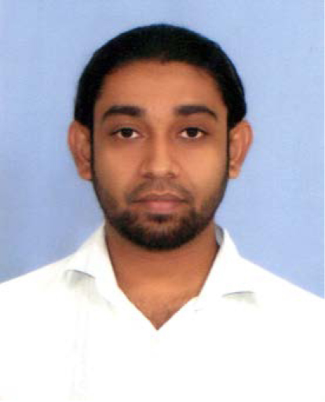
Muhammed.338035@2freemail.com

Objective:
To utilize my professional and life skills experience with the intention of securing a professional career with ample opportunity to tackle challenges and advance, while continuously building on my library of knowledge and skills.

Personal Strength:
Making complex tasks easy and Being creative. Always look for the best, but also most practical solution to enhance the value of the business.

Work Experiences:
Sales Representative 2016 to present
YogaTrippie FZ LLC
Job description:
Working as an ecommerce Sales personal / Authorpreneur

Sales Executive, Graphic designer 2011-2016
Buydaddy LLC.,
Bur Dubai, UAE
Job Description:
- Expressing Visual communication and presentation for the online business
- Concepts and designing Company logos and branding, Advertising [visiting cards, brochures, Cartons, Bags, Export Packing, Web site art work and layout changes so on…].
- Handling online and retail sales and marketing
- Packing and Delivery

Graphic designer 2008-2011
J. Zahirsha Bros [Pvt] Ltd.,
No. 15 Second level, Haig Road
Colombo 04, Sri Lanka
Job Description:
- Expressing Visual communication and presentation for the tea export business.
- Concepts and designing Company logos and branding, Advertising [visiting cards, brochures, and Tea cartons, Bags, Export Packings' so on…].

Free lance Advertising work on my own... 2002-2008

Commercial Artist 1999-2002
Blitz CVN.,
165 Vipulasena Mawatha
Col 10, Sri Lanka
Job Description:
- Producing art designs for promotional materials and commercials.
- Helping out the Creative director and Art Director in expressing their creative ideas as part of the creative team, by the use of DTP so􀅌ware packages [Corel Draw, Photoshop] and personal suggestions and concepts.

Educational Background:
GCE O/L 1996, Wesley College, Col 08, Sri Lanka 1985-1996
Curricular Activities:
- Member of the College Islamic Society
- Member of the College Electronic Club
- Member of the College Road Safety club
- Played soccer for the College Team [Under 14 and under 16].

Professional Qualifications:
Certification in WEB DESIGNING 2005
NIIT., Union Place, Col 01, Sri Lanka

Certification in MICRO BASED TRAINING [Desktop Publishing, Printing]. 2001
International Business Systems Overseas [Pvt] Ltd., Col 03, Sri Lanka

PRACTICAL ENGLISH Certification [with a Credit remark]. 1998
Royal Institute., Col 6, Sri Lanka

Special Skills:
Computer Literate: familiar with a number of DTP Packages [Corel DRAW, Photo shop...].

Personal Information:
Date of Birth January 29, 1980
Place of Birth Maradana, Sri Lanka
Age 36 years old
Sex Male
Civil Status Single
Nationality Sri Lankan

I do here by acknowledge that the above given particulars are true and accurate to the best
of my knowledge.

