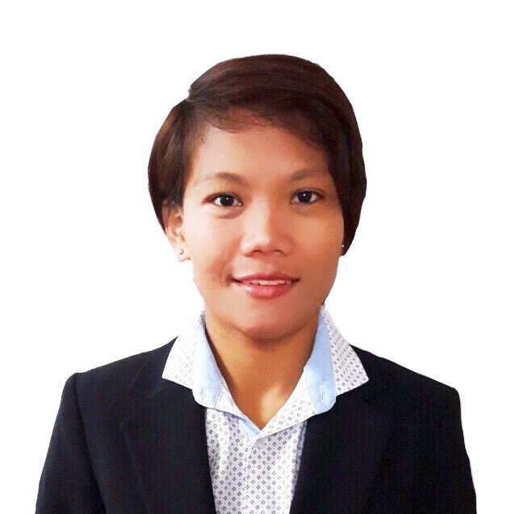
CARMI
Registered Nurse
E-mail: CARMI.338081@2freemail.com

OBJECTIVES:
To serve as a registered nurse in a hospital where I can make the most of my education and training.
To enhance my knowledge and share my skills into highest level of patient care.

QUALIFICATIONS:
Registered Nurse (Special Professional Licensure Board Exam, September 2016)
Abu Dhabi, UAE

Motivated and with outstanding skills in dealing with patients for 8 years of experience as a nursing staff.

Ability to think quickly and successfully handle difficult and unpredictable cases.

EDUCATIONAL BACKGROUND:

Tertiary: BACHELOR OF SCIENCE IN NURSING (BSN)
Jose Rizal University
80 Shaw Blvd., Mandaluyong City,
2004 – 2008

Secondary: Catalino D. Salazar National High School
Purok 6 Brgy. Subay Cardona, Rizal
2000 – 2004

Primary: Subay Elementary School
Purok 1 Brgy. Subay Cardona, Rizal
1994 – 2000

PROFESSIONAL LICENSE:

Licensing Body | Professional Regulation Commission
Professional Status | Registered Nurse
Registration Date | December 13,2016
Validity Date | September 30,2019

WORK EXPERIENCE:

OPERATION THEATER-NURSING ATTENDANT-(February 2015 to present)
Brightpoint Royal Women's Hospital, Muroor Road, Abu Dhabi

- Assisting the doctors and nurses in the Operation Theater department.
- Prepare patient for the operation from pre-operative area to OT table until post
operative unit and other related duties as directed by and under supervision of the nursing personnel.
- Guides and assists patients and relatives as they arrive in the operation theater and respond swiftly to patient request assistance.
- Checks monitoring machines are always working
- Assists in procedures as a circulating nurse inside the OT with the nursing personnel.
- Assists the nurse in-charge in replenishing supplies and checking all the consumable items in the OT store.

IN-PATIENT WARD-NURSING ATTENDANT -(February 2014 – February 2015)
NMC Specialty Hospital, Electra Road, Abu Dhabi

- A routine task under the supervision of a senior nursing and medical staff.
- Assists patients as they arrive in the ward and ensures the availability of a wheelchair when needed.
- Sets up equipment, store and ensuring stocks and supplies and assist in some procedures.
- Sending laboratory samples for investigations and accompanying patients to other respective departments as referred.
- Observes patients physical, mental and emotional condition, and report any changes to senior nurses and medical staff.

GERIATRIC NURSE – Nursing Home (August 2011 – July 2013)
Al-Faiha Medical Center, Riyadh, Saudi Arabia, KSA

- Develops and implements nursing care plan
- Educates patients and relatives about health maintenance and disease prevention
as primary care.
- Responsible for overall delivery of basic nursing care to the patients:
  - daily dressing
  - bathing and feeding the patients as a daily routine
  - taking vital signs and glucose monitoring.

MEDICAL WARD -NURSING ASSISTANT (April 2008 – December 2008)
RPG–PHO Rizal Provincial Hospital, Morong, Rizal, Philippines

- Contributing to the provision of the high standard of patient care under the supervision of the nurse in charge
- Observing and recording of patients' condition
- Taking vital signs and giving proper oral medication
- Inserting IV cannula with the supervision of senior nurse and securing the safety of the patient.
PERSONAL SKILLS:
- Excellent interpersonal skills and the ability to work well with different personalities in both supervisory or support staff roles.
- Trainable and a fast learner
- Can work with less supervision and under pressure
- Able to multitask
- Has self-discipline and determination needed in right training
- Proficient in both written and spoken English
- Understands and speaks basic Arabic
- Computer literate

AFFILIATIONS/ORGANIZATIONS:

Filipino Nurses Association in Emirates (FNAE)
Member, December 2016

Philippine Nurses Association (PNA)
Member, December 2016

