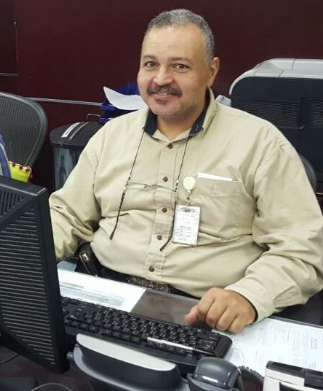Yahya
Yahya.338088@2freemail.com
Personal Information
Nationality :Jordanian
D.O.B : November 26th.1966
Profile: Male, Married
Preferred Location: Not specified
Salary Expectation: Not specified
Address : Almaqam Alain ,UAE
Education
Oct 1992 Security Officers Training Academy, California USA .
- Fire Arms Course.
- Side handle Baton.
- Power to Arrest.
- MEDIC FIRST AID (CPR/ First Aid) .Authorization number .
Oct 2001 Computer course (windows,word,excel,power point), Ibn Khaldoun Institute,alain UAE. Jan 2005 Basic Medical Terminology , Tawam Hospital Approved by the California Board. Jun 2008 BLS American Heart Association , Tawam Hospital LSTC (BLS for healthcare). Oct 2016 Sign language , Zayed Higher organization First level, Alain UAE.
Objective
To actively Pursue employment opportunities with a progressive Organization, Which will effectively utilize my experience and proven capabilities to get a position in your organization .

Experience
Sep 2003-Present Tawam Hospital, Alain UAE
Patient Access Representative ,Patient affairs
- Registering patients in computer ,writing history of disease of patient.
- Up date patient information ,scan patients ID and Insurance card in cerner.
- Booking patients appointment in out patient clinics .
- Submit insurance forms to get approval from insurance main office .
- Follow up with insurance companies to get the Approvals.
- Interrupting between nurses and patients .
- Open cash drawer to collect co-payments,Deposit money for self pay patient.

Aug 2002- Aug 2003 AlBustan center & Resident Dubai, UAE
Asst. Chief Security ( Acting Chief Security )
- Directly in charge of security department.
- Control daily operation ,Distributing security officers
- Responsible of 640 deluxe furnitured apartments
- Responsible of shopping mall ,swimming pool and Dubai festival coupons.

Aug 1998 -Aug 2002 Tawam hospital , Alain UAE
Asst. Security Officer
- Directly Responsible of hospital property
- Provide safe environment for employees ,patients and visitors
- Control and oversee visitors behaviors
- Patrolling Jahili clinic and Dental center .
Aug 1985to Aug 1990 Kuwait Airways (Kuwait )
Aircraft Mechanic
- Preparing airplanes for takeoff and landing
- Completing transit and major check
- Quick maintenance for engine and air frame on Boeing and Airbus
- Clear defects on pilot tech log .

