JOCELYN
JOCELYN.338091@2freemail.com 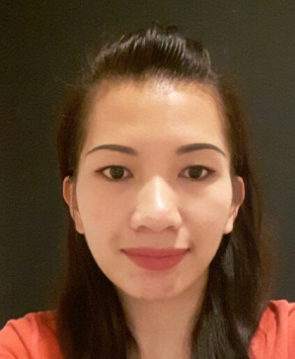

OBJECTIVE
I want to be a part of success in an environment of growth and excellence.

WORK EXPERIENCE
- Sales Associate for 2 years in Expressions Stationary Shop / Mart One Department Store
- Sales Team Leader for 1 year in Expressions Stationary Shop / Mart One Department Store

EDUCATIONAL ATTAINMENT
- High School Graduate
- PC Operation ( vocational )

PERSONAL STRENGTH AND ATTRIBUTES
- Good Communication , self confidence, discipline , honest
- Pleasing manners and can easily get along with other people
- Interested to learning more

COMPUTER SKILLS
- MS Office

CERTIFICATES / AWARDS
- EMPLOYEE OF THE MONTH
- EMPLOYEE OF THE YEAR 2013 and 2014
PERSONAL PROFILE
- Date of Birth : 14 March 1992
- Gender : Female
- Nationality : Filipino
- Religion : Christian
- Marital Status : Single
- Language : English, Tagalog and Ilocano

PASSPORT DETAILS
- Date of Issue : 10 NOV 2015
- Date of Expiry : 09 NOV 2020
- Place of Issue : DFA TUGUEGARAO
DECLARATION
I hereby declare that the above information is correct and true to the best of my knowledge.

