Mr. Christian
Christian.338093@2freemail.com

Dear Sir/Madam,
Upon reading the job description you have posted, I am writing to express my strong interest in working at your company as an Administrative Staff/Customer Service Representative. I am certain I would be a perfect fit for the position at hand. I am extremely computer efficient, and make an excellent assistant/office administrator/support for all who are in need of it in the office when necessary. I possess very good listening skills, am not afraid to ask questions, and am extremely straightforward, acting as a key problem solver when issues may arise.
I am a highly capable and experienced administrative professional. In addition to my administrative skills, I offer significant abilities and experience in organizing, prioritizing, confidentiality of documents, and detailed preparation of reports and projects.
My ability to get along well with others, to make necessary adjustments to meet deadlines, and effectively coordinate in fast-paced environments have all contributed to my growth in this field and my employers placing a significant degree of trust in me.
I have excellent creative way of thinking and a hard working invidual. I enjoy designing plans and seeing in the way it comes together.
I have enclosed a copy of my CV which shows my experience. If you are interested in my details please do not hesitate to contact me and I will be happy to answer any questions you may have with regards to my application.
Thank you for taking the time to read my application and I look forward to hearing from you.

Yours Sincerely

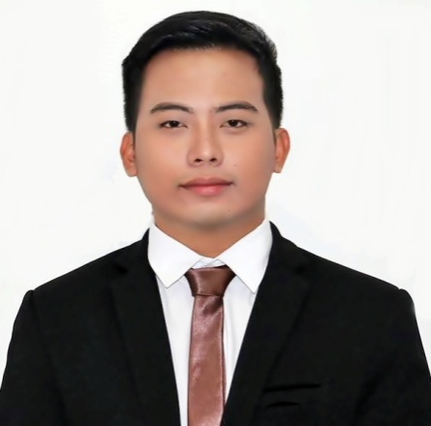
CHRISTIAN

OBJECTIVE
To join a highly professional and dynamic organization where I can utilize my best knowledge, my multitasking abilities, creative skills in planning, organizing and vast work experience to grab ample of career progression

WORK EXPERIENCE

December 2015 – October 2016 Event Director/Coordinator
ADFIAP International CEO Forum
New World Hotel Makati Philippines

- Negotiated and maintained long term vendor partnerships resulting in a sponsorship
- Managed, coached and mentored the annual giving and event project coordinator; oversaw their production and professional development to achieve a cohesive team and successful events.
- Supported all leadership decisions, goals, vision, and mission and promotes diversity and teamwork.
- Managed overall planning of special events (including logistics, budget, sponsorship, promotions, marketing, organization and analysis of information.)
November 2014- November 2015 Training Facilitator
Educational Research and Development Assistance
(ERDA) Foundation Inc. A Non Government Organization

- Highly skilled in developing reports required for managing internal and external meetings between parties
- A self-motivated individual with abilities to face and overcome challenges individually.
- Effective communication skills that help explain finer details to members articulately.
- Detail-oriented individual with high regards to correctness and quality in work
- Ability to perform tasks controlling and assessment functions
- Superior problem identification and solving skills. Good team player with leadership skills

October 2013- October 2014 Customer Service Representative (CSR)
One World Connection UK Based Company,
Ortigas Business Center, Pasig City Philippines

- Managed the escalated service and Maintained relationships with our clients.
- Submitted requests to the proper department to prevent re-occurring issues and recommend Improvements in the process and procedure.
- Analyzed reports on improvements to bring effectiveness to the department
- Promptly and methodically responded to customer inquiries to identify and resolve issues with initiative and good judgment.
- Multi-tasked systems while providing service and resolving customer issues, upgrades, etc.
- Responded to and handled customer complaints and inquiries in a timely manner
- Maintained a high-volume workload with a polite and professional telephone manner
- Developed personal organization and multitasking skills in a fast paced environment

EDUCATION
2009-2015 Polytechnic University of the Philippines
Bachelor of Science in Architecture

2014- Autocad 2014 Leading to Technical Drafting (2D) NC II
Microcadd Institute Inc. (Autodesk training center)

2014- 3D STUDIO MAX 2014 for Architectural Design
Microcadd Institute Inc. (Autodesk training center)

SKILLS SUMMARY

- Design expertise -developed through studies
- Proficient in AutoCAD, Autodesk 3D Studio Max.
- Computer – MS Office Suite and MS Project
- Basic Photoshop and Video Editing
- Highly developed verbal and written communication skills demonstrated through consistent distinction results for training under stage productions and facilitating seminars.
- Demonstrated ability to understand the need of assigning relevant responsibilities and monitoring project progress
- Profound experience in leading teams in order to ensure clear mitigation of risks and issues
- Hand on experience in managing events for promoting projects and developing awareness.

PERSONAL INFORMATION
Language speaking: English and Filipino

