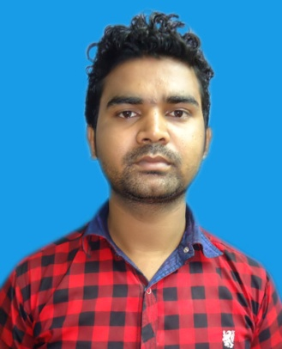
CURRICULUM VITAE

Waise
Waise.338110@2freemail.com

Objective
- To Have a Clear Vision in achieving organization’s goal and management objective.
To work for organization where maximum potential ability.

Experience

- Worked as storekeeper maintenance warehouse by operating Tally Erp9 & Microsoft Excel in “Soumya Mining Pvt. Ltd. From ”10th October 2013 To 17th November 2014.
.
- Worked as Storekeeper Maintain Of spare parts of warehouse by Data operating in Tally Erp9 & Microsoft Excel in “Swift Equipment Pvt.Ltd.” The (Authorized Dealer of Lugging India Pvt.Ltd) 02nd Dec. 2014 to 20th Dec. 2016

Educational Qualification

Course School/College University/Board Year Division
Metric BGH high school J.A.C (Ranchi) 2006 2nd
Loyabad 45%

Inter Mediate S.S.N.M College J.A.C (Ranchi) 2010 2nd
Sijua 55%

Technical Qualification
- Diploma In Financial account In Tally Erp9 From (Bhaloti Computer Institute “Jharia”)
- Ms Excel, Ms Word, Ms PowerPoint Photoshop From (Doacc “Ranchi”)

Hobbies

- Showing Movies
- Computer Operating
- Holiday Enjoying

Personal Details
Date of Birth : 18th May 1989

Sex : Male

Blood Group : O⁺

Height : 175,cms

Nationality : Indian

Language Known : Hindi, English

Declaration
I hereby declare that all the above said information’s are true to the best of my knowledge.

