CURRICULUM VITAE

SENOJ  SENOJ.338113@2freemail.com  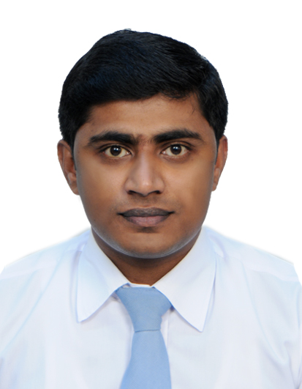  Key Skills  ➢ Good team Player  ➢ Capable to adapt to changing situations  - Honest and Sincere  - Good listener and observer  - Good problem solving capability  Personal Data  Date of Birth : 12/07/1986  Sex : Male  Nationality: Indian  Marital Status: Married  Languages Known  - English  - Hindi  - Malayalam  - Arabic (verbal only) | Objective  To work with dedication , sincerity , commitment and utilize  my professional potential and capabilities so that I could be  a part of the constructive activities of the organization.  Experience and Qualification  EXPERIENCE:  - At present working as Branch Manager and optometrist  in Optica , Dubai since October 2014.  - Worked as Branch Manager and optometrist in  Optica (former Bahrain optician) , Kingdom of Bahrain  From April 2010 - October 2014.  - Worked with Lawrence & Mayo Opticians , Cochin  From August 2008 - March 2010.  Major Responsibilities:  - Basic Optometric eye checkup including refraction.  - Dispensing spectacle and contact lens.  - Help customer in selecting spectacle frames and  make recommendation.  - Lifestyle dispensing  - Contact lenses and eyeglasses troubleshooting  - Handling stock inventory  - Stock replenishment for eyewear and contact lenses  and solutions  - Arranging duty schedule for the branch  EDUCATIONAL QUALIFICATION:  - Bachelor In Clinical Optometry ( B. OPTOM), 2004-2008  - Medical College School of Optometry, Bharati Vidyapeeth University,Pune,India.  - 12th grade 2002-2004  - Board of Higher Secondary Examination, Kerala,India.  - 10th Standard 2002  - Board of Secondary School Examination, Kerala,India.  Strengths & Qualities  - Self Confident and hardworking  - Self motivate and quick learner  - Good knowledge of computer application.  - Good verbal and written communication skills  Declaration  I hereby declare that the above furnished details are true and  Correct to the best of my knowledge.

