MO
MO.338117@2freemail.com
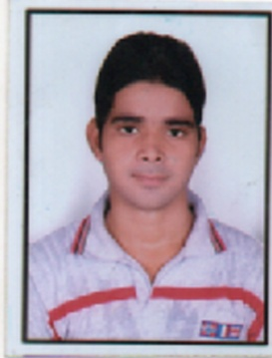

OBJECTIVE:
To obtain a respectable position within a growth oriented, progressive company. I want to apply my exceptional interpersonal, marketing and communication skills to an environment where they will make a significant impact on the bottom line. To engage myself with professionally satisfying assignments, leading to enrichment of knowledge, and constant improvement of my conceptual and technical skills.

ACADEMIC (QUALIFICATIONS):
DEGREE | INSTITUTION/BOARD | YEAR | DIVISION
D PHARMA | SCHOOL OF PHARMACY (BTE, Lucknow) | 2013-15 | 1ST
INTERMEDIATE | S.D.P. INTERCOLLEGE- U.P. BOARD | 2013 | 1ST
HIGH SCHOOL | S.D.P. INTERCOLLEGE- U.P. BOARD | 2011 | 2nd

- Done certificate course in Diploma in Computer Applications.
- Done certificate course in Office Applications.

WORK EXPERIANCE:

- Three Months Internship as a Pharmacist at Civil Hospital, Jaunpur, U.P.
- Have worked as a Hospital Pharmacist at Amina Memorial Hospital, Shahganj, U.P.
- I have 15month experience of Medical Representative in “Miral Pharmaceutical” Gurgaon India.

EXTRA CURRICULAR ACTIVITIES:

- Participated as a member of student management in a pharmaceutical
conference conducted by college.

COMPUTER SKILLS:

Microsoft Office: MS word, MS excel, MS PowerPoint.
Operating System: WIN XP, VISTA, WINDOWS 7.
Internet: Knowledge of Internet.

STRENGTHS:

- Achievement oriented with an ability to manage change with ease
- Strong communication, interpersonal, learning and organizing skills
- Ability to manage stress, time and people effectively
- Have the ability to tackle complex issues in creative ways.
- Quick learner with a positive attitude
Soft skills such as interpersonal communications, ability to work collaboratively and
commitment to achieving corporate goals

PERSONAL DETAILS:

Name : MO
Date of Birth : 21th APRIL, 1995
Marital Status : Unmarried
Gender : Male
Nationality : Indian
Visa Status : On Visit Visa till 9/Feb/2017

