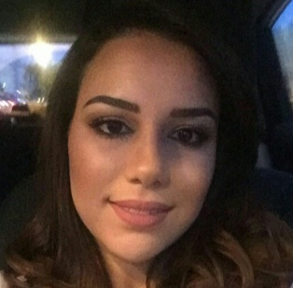
Ghizlane.338123@2freemail.com
Ghizlane

Education | Année  22013-2015 : Specialized technician diploma « Responsible for processing banking and transactions” at the international training center of banking professions (CIFPB) in CASABLANCA.  Anné e 2011-2012 : First year at the university of economics and management in MOHAMMEDIA.  Année 2010-2011 : Baccalaureate option physical and chemical sciences at high school Aljoulane MOHAMMEDIA.
Career history | April 2016 – January 2017 : Assistant Manager at ADEIS CONSEIL  - Managing the administration aspects of real estate sales  - Operational management of customer contracts  - Classification of accounting documents  - Validation of commercial medias : advertising inserts, sales brochures, logos…  December 2015 : Membership consultant at PASSAGE FITNESS  - BtoC direct selling and managing the administrative side, Customer focus  - Recovery and monitoring of customers’s files  - Phone prospecting and direct marketing  March –July/2015 : Telemarketer BtoB at IMA TELEVENTE  - Selling law books and digital solutions of éditions francis lefebvre  - Preparing quotes and sending commercial propositions  - Demonstration of the digital solutions to the customers and objections treatment  April 2014 : Internship at La Banque Centrale Populaire – Maarif agency  - Front desk and cashier  - Accounts opening  April 2012/September 2013 : Technical assistant - the hotline Orange at PHONE GROUP  - Receiving calls, customer assistance  - Taking records, objections treatment  - Promotion of the new products and services
Skills and interests | Languages : French : Fluent ,  English : intermediate,  Arabic : fluent.  Skills : develop client portfolio, ensuring customer care, sales technics and trading, customer orientation…  Computing : Microsoft word, excel , powerpoint.  Interests : Traveling, reading, decoration, music…

