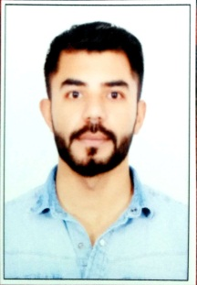
GAURAV
GAURAV.338138@2freemail.com

Objective
I am seeking a responsible and challenging position, which can tap my potential in a growth oriented professional organization where the association is mutually benefited. I am an able person to go for minute details and can make decision as and when required.

READY TO JOIN IMMIDIATELY

Education Qualification
- Bachelor of Science (Bsc IT), GNDU, Amritsar, Punjab, May 2012.
- XIIth, PSEB Mohali, Punjab, April 2008.
- Xth, PSEB Mohali, Punjab, March 2006.
- Web designing from GTB Institute Jalandhar
- Well versed with MS-Office and Internet.
- CCNA security
- Networking and hardware from jetking institute jalandhar.

Skills

- Windows Xp, 7,8,10, Ms Office, Internet, email, fax, scan, Internet, scan, 40-45 wpm typing speed,
- Web desiging,dreamweaver,HTML,CSS3,jquery.animations,photoshop,bootstrap,less,saap,
- IT technician
- Networking and Hardware
- Excellent oral and written communication skills
- Ability to deal with people diplomatically
- Excellent analytical mind to perform initial troubleshooting of computer console systems
- Confident and always positive thinking

Experience
- Experience in computer operator
          - Windows Xp, 7,8,10,
          - , Ms Office
          - Internet, email, fax, scan
Computer hardware

- Experience in web designer

Hobbies
- Listening Music,Traveling,Cricket And Internet Surfing

Personal Details
- Unmarried
- English, Hindi and Punjabi proficient
- Nationality-Indian

