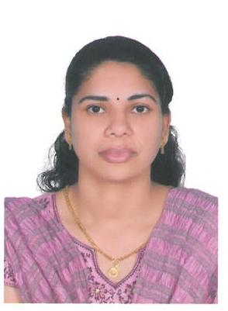 | Beena  Beena.338168@2freemail.com

Summary.
- Strong knowledge of the diagnosis, treatment and medical practice.
- In-depth knowledge of the medical terminology and procedures.
- Exceptional communication skills both orally and written.

Career Objective

- Looking to further my experience as a staffnurse in a busy and professional environment.

Skills Summary
- Remains calm and professional during times of critical need.
- Readily develops rapport with patients, staff and physicians.
- Proven record of reliability and responsibility
- Excellent skills in handling patients with their problems, queries and complaints.
- Very effective leadership and instruction qualities.

Registration

HAAD Licensure for Practical Nursing. LICENSE NO:

Employment History

- Worked in Pushpagiri Hospital for ONE YEAR in LABOUR ROOM&OB&GYNAE wardThiruvalla, Kerala, South India -2000-2001

- Worked in new delhi hospital settings FOUR YEAR inMED&SURGICAL AND OB&GYNAE ward-2001-2005

- Worked In Al Rass General Hospital under MOH for FIVE YEARin OB&GYNAE Ward as registered nurse–ALRass, SAUDIA ARABIA 2005-2010

- Worked in BIN SULAIMAN MEDICAL CENTRE AL AIN-2011-2013

- Worked in AL FARABI MEICAL CENTRE AL AIN-2014
- Worked in NMC SPECIALITY HOSPITAL AL AIN 2014-2016

Education and Training

SSLC – ST Theresa Bethany Convent School, Chenganoor, kerala ,india

PDC – BAM College Thiruthicadu, kerala,india

Diploma in General Nursing Midwifery - Pushpagiri Hospital, Thiruvalla, kerala, india-1997-2000

Languages Spoken

English, Arabic, Hindi &malayalam

ON HUSBAND VISA

