RESUME:-FINANCIAL EXCUTIVE

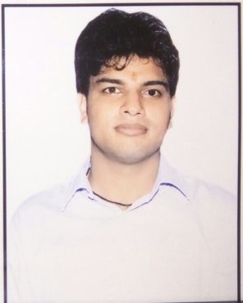
RAMAWATAR
Ramawatar.338177@2freemail.com

CAREER OBJECTIVE

To execute and manage a challenging responsibility in a growth-oriented and dynamic organization that can offer opportunities to use my skills and enhance the growth of the organization.

PERSONAL SUMMARY

An ambitious, motivated and energetic accounting executive with excellent auditing and business development skills. Experience of managing accounts and auditing for established hotels, automobiles, manufacturing and construction industries . A result orientated professional with a proven ability to get results, improve service as well as reduce costs.

PROFESSIONAL EXPERIENCE

- JAGDISH D. SHET & CO. - As ARTICLE ASSISTANT
Involved in the strategic Audit planning for the companies, partnership firms, proprietor, Organized audit operations and major events like promoting new audit techniques. [APRIL 12 - AUGUST 15]
- Experience of account management and client relations and retention.
- Experience of Statutory Audit, Vat Audit and Tax Audit.
- Writing detailed Audit forecast report for senior company managers.
- Gathering industry data and analyzing the spending patterns to highlight the potential for future growth.
- Communicating amendments in Tax, Accounting Standard to clients.
- Experience in Individual Return Filling, TDS Certificate Generation.
- Experience of working on different accounting software

MAJOR TRAINING

- JAGDISH D. SHET & CO. - As ARTICLE ASSITANT
[APRIL 12 - AUGUST 15]
- Certificate of Completion of Articled Services issued by ICAI.
- Certificate of Intermediate (Integrated Professional Competence) Examination.
- Certificate of Orientation Programme issued by ICAI.
- Certificate of Computer Training Course issued by ICAI.

ACADEMIC CREDENTIAL
Qualifications | College/ School  (University/Board) | Year | %
C.A. Final Pursuing | The Institute of Chartered Accountants of India
M.Com | University Of Rajasthan | 2013 | 56
B.Com | University Of Rajasthan | 2011 | 55
12th/ HSC - | Seth Shri Sagarmal Bagrodia Senior Secondary School  (State Board) | 2008 | 66
10th / SSC | Seth Shri Sagarmal Bagrodia Senior Secondary School  (State Board) | 2006 | 60

POSITIONS OF RESPONSIBILITY

- Sports Captain in School - Organized many inter- school sports event, as a sports captain and also Organized & Handled the Cultural events in School and College.
- Administrative Head at Shri Sradha Nath Ashram.
- Chief organizer for Winter Project 2008: District Level cloth distribution campaign that covered more than 1000 people.

AWARDS AND ACHIEVEMENTS

- Won 1st prize in School Attendance & 1st prize at Drawing Competition

EXTRA-CURRICULAR ACTIVITIES

- Won Silver medal at Indian development foundation in Resource Mobilization for Humanitarian Causes.

PERSONAL DOSSIER

- Gender - Male
- Date of Birth - 29th January, 1990
- Marital status - Married
- Nationality - Indian
- Hobbies - Sports, Listening Music and Dancing
- Languages Known - English, Hindi

Extra-Curricular Activities.

Computer Skills – M.S. Office, Tally 9.0, ERP
Language Known: Hindi, English.

Declaration:
I consider myself familiar with my Work. I am also confident of my ability to work in a team. I hereby declare that the information furnished above is true to the best of my knowledge.

