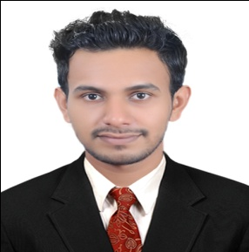
BULAYALAM
BULAYALAM.338238@2freemail.com

OBJECTIVE:
Intend to build a career with leading corporate environment with committed and dedicated people, which will help me to explore myself fully and realize my potential Willing to work as a key player in challenging and creative environment.
WORK EXPERIENCE:
Worked as accountant for the period 6 months in ‘B Supermarket’ in Kasargod.
As Part of Internship in completion of MBA course, worked in Kasargod Service Co-operative Bank. Which mainly dealt with Financial Performance Analysis of the Bank for the Past Five years.
PROJECT UNDERTAKEN:
“Analysis of Financial Performance with reference to Kasaragod Service Co-operative Bank, Kasaragod”.

EDUCATIONAL QUALIFICATION:
- Post graduation : MBA in Finance and Marketing, (First Class) at PA College of Engineering (VTU) 2016.
- Graduation : B.Com from Kannur University(2014)
- Intermediate : P.U.C (Commerce) P U Board of Kerala, India.2011
- SSLC : Central Board of Secondary Examination (CBSE). 2009

EDUCATIONAL ACHIEVEMENTS:
- Selected as Chairman of College Students Union.
- MC for various college programs.
- Participated in several national level management fest.

TECHNICAL SKILLS:
- Tally.
- MS Word, Ms Excel, Ms Power Point, Internet (Basics)
- Photoshop.
PERSONAL STRENGHTENS:
- Quick Learner
- Strong Communication
- Good English writing skills
- Approachable with strong leadership qualities
- Keen observant

PROFILE SUMMERY:
- A dynamic and multitalented professional with exceptional financial knowledge having degree of MBA.
- Experience in all the financial aspect and policy for business aspect.
- Expert in implications of new financial policy for the new business development.
- Proficient in identifying the new resources of funds and also invest them for getting good revenue.
- Excellent in utilization of all resources

PERSONAL PROFILE:
Date of Birth : 03-NOV-1992
Sex : Male
Nationality : Indian
Marital Status : Single
Languages Known : English, Hindi, Malayalam
Visa Status : Visit Visa (Expiry Date – 15th March 2017)

DECLARATION
I, affirm that the information given above is true and correct to the best of my knowledge and belief.

