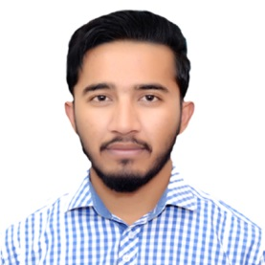
Abdul
Abdul.338243@2freemail.com

OBJECTIVE:
Seeking a position where I can utilize my skills in career opportunities. I am an out going high energy person and want to do work for my safe future. I want a suitable place for job.

PERSONAL DETAILS:
Date of Birth : 03-06-1992
Nationality : Pakistani
Marital Status : Single
QUALIFICATION

- Matric KARACHI Board 2013
- Hafiz Quran Jamia Madina Farooq-e-Azam 2009
Experience:
6th Month Job in Warid Telecom

LANGUAGE________________
Urdu,English & Punjabi.

Refrence:

Will be furnished on Demand.

