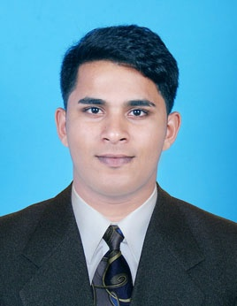 | AMEER  Email: AMEER.338246@2freemail.com

CAREER OBJECTIVE:
- To achieve a position given an opportunity to gain my knowledge while contributing creative solutions to the advancement of the organisation in work.

PERSONAL STRENGTH:
I am very Positive, Flexible, Trust worthy and Customer handling techniques to handle variety of Customers.
KEY COMPETENCIES:
- Having experience in Customer Service Executive and as a Cashier in India.

PROFESSIONAL EXPERIENCE:
- Worked in PENINSULA GRAND HOTEL MUMBAI AS FRONT OFFICE EXECUTIVE
(From 20th May 2015 to 25th May 2016)
- Worked under a CHARTERED ACCOUNTANT (From 01st June 2016 to 10th January 2017)

Key Result Areas:
- Responsible for the day-to-day operations and co coordinating the General Manager with development activities.
- Delivering best customer service, beyond all expectations by giving best customer service to all type of customers.
- Working as a team and we make sure that customer is been satisfied.
- Patience to listen and sort out customers issues.
- Handling Night reports and Cashier Handling.
- Able to take the Initiative to address the tricky issues.
- Able to ensure sales targets are met and exceeded beyond expectations.
- Able to give exact and detailed information to customers.
- Recording sales, purchase, daybook & ledger book.
- Following up sales orders specifically with the deliveries and payments received from our customers.
- Coordinating with travel agencies for reservation of Intentional Air tickets for the customer.

ACADEMIC QUALIFICATIONS:

- Bachelor Of Commerce in Upendra Pai Memorial College under Mangalore University in 2013.
- Pre Degree in Mahatma Gandhi College kunjibettu in 2010.
- S.S.L.C in Mahalakshmi English Medium Uchila in 2008.

OTHER QUALIFICATION:
- Diploma in Aviation, Hospitality and Travel Management, ICM UK CERTIFIED.

TECHNICAL SKILLS:
- Having a sound knowledge of Tally erp 9, Excel.

ACHIEVEMENTS:
- Awarded in Karate and Swimming.

PERSONAL PROFILE:
- Sex : Male
- Date of Birth : 16 Aug 1992
- Nationality : Indian
- Civil Status : Single
- Religion : Islam
- Languages : English, Kannada, Hindi ,Tulu and Malayalam
- Visa Type : Visit Visa (Valid upto 15th March 2017)

I certify that the above mentioned information is True and Correct to the best of my knowledge.
Yours Truely,
AMEER H
Applicant

