ENJOY YOUR WORK (JOB) AS IT IS AN ESSENTIAL AND IMPORTANT PART OF YOUR LIFE
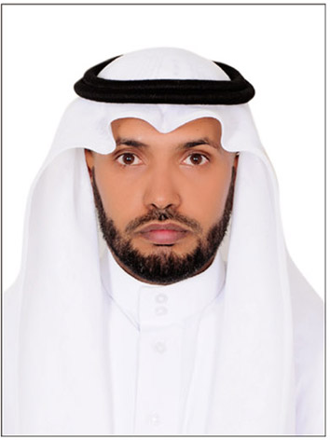
12th of January, 2017
NAME: Ali
Ali.338331@2freemail.com
BIRTH: 1402 AH – 1982 AD
QUALIFICATIONS:
B. A. in English Language Teaching 2004 – M. A. in Translation(Arabic--»«--English) 2016
EXPERIENCE AND JOB TITLE:
About 13 years in Education as follows:
- 8 years as an English Teacher and was in all Grades of Public Education.
- 5 years as an English Supervisor in Al Dayer Education Office.
COURSES:
More than 20 courses, programs, meetings and workshops in the field of Education as a trainer and a trainee. There are documents available.
CERTIFICATIONS:
- Course certificates in the field of Education.
- Course certificates in other fields.
- Appreciation certificates and letters.

COMPETENCIES:
1. Personal Skills (integrity and ability to participate dynamically within a goal-driven team)
2. Communication & Presentation Skills (Ability to present training materials, write, and speak effectively)
3. Leadership Skills (Ability to work collaboratively and creatively as an SDU team member and team leader)
4. Computer Skills (Ability to use Microsoft Applications effectively)
5. Self-Management Skills (Ability to plan work activities and meet deadlines)
6. Technical Skills
6.1 Ability to develop, prepare, and conduct SDU-related programs and workshops
6.2 Demonstrate excellent ability in training delivery
6.3 Has competencies to develop programs that improve the quality of company training
6.4 Ability to conduct on-site certification follow-up visits to observe trainers, mentors, and evaluators in their work sites to ensure application of acquired skills for the certification
MY VISION
Human being was created to build on earth in two ways: First, spiritually by worshipping Allah the Almighty; this is the way regulating and organizing the coming one ( life on earth which is the second way ). Second, by using natural things and materials whether as they are or after being made by humans; this is the usual way people think of when it comes to building on earth. So, everyone should have a vision, goals and a mission to ease his way and to be on a sound ground. Self development and improvement ( self change vision ) is an important factor in continuing, keeping and increasing production in all levels including the personal level. So, being up to date helps much. Many ways can be followed and used to carry out such development such as reading, searching and studying etc. That means you have to try to drive a large and great change in order to live well not only for yourself but also for the organization (FAMILY) that you belong to.

