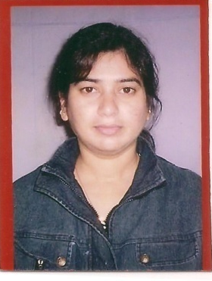
Page 1

Anita
Profession: Civil Engineer

Email: Anita.338355@2freemail.com

PROFILE
To be part of a team in a reputated company where, I would get ample opportunities to take challenges and responsibilities and to grow with the organization to master my professional and personal life.

PERSONAL PROFILE
Academic Qualification : ADMINISTRATION
Computers : Well versed in usage of computer
Driving License : Having U.A.E License
Date of Birth : 5th Oct 1976
Nationality : Indian
Visa Status : Residence Visa
Professional Experience : 19 years
Office Administration : 09 years
Civil Engineer : 09 years
UAE experience : 9 years since 2006

From June 2008 to 2016
Torento Building Cont. Co. LLC
Civil Engineer & PRO work
- To manage day to day responsibilities
- Maintaining systematic record keeping
- All municipality building work permit related work
- Sites inspections and check work schedule
- All visa formalities for new comers

From June 2006 to 2008
Jazeera PORT Govt. of Ras Al Khaimah
Marketing Assistant
- Coordination between the clients and the director
- To manage day to day responsibilities
- Liaise between the reporting manager and other Head of the Department
- Maintaining systematic record keeping
- Execution of the jobs with in the specified time frame

Page 2

From June 2005 to 2006 date
Govt. of RAK PORT (Passenger Terminal) Dubai & Ras Al Khaimah
Office Administrator
- Front Office Management
- To manage day to day responsibilities
- Liaise between the reporting manager and other Head of the Department
- Handling Passengers and their complaints and suggestions
- Coordination between the travelers and terminal management
- Preparing front office staff duty schedule
- Maintaining systematic record keeping
- Execution of the jobs with in the specified time frame

From 2000 to 2005
M/s Royal café (Hotel) India
Office Administrator
- Arrange appointments and meetings
- Handling enquiries, complaints and suggestions
- Handling incoming and outgoing faxes and other documents
- Systematic control of filing and documents
- Attend interpersonal inquiries
- Handling incoming and outgoing telephone calls
- Administrate front office staff
- Travel arrangements for sr. officials
- Maintaining staff record

From 1996 to 2000
City Convent School
Office Administrator

- Computer training for basic software to school children up to 10th grade.

STRENGTH

- Work efficiently under pressure
- Proactive attitude towards work
- Computer literate and quick adaptability
- A keen attitude to accept challenges & fulfill goals
- Dynamic and charming personality

Page 3

ACADEMIC QUALIFICATION

- BE Bachelor of Engineering INDIA
- Diploma in computer Programming From Aptech INDIA

COMPUTER SKILLS AND LITERACY

- C, C++, Java, Oracle, Foxpro, MS Office, and internet application with excellent working knowledge

ANITA

