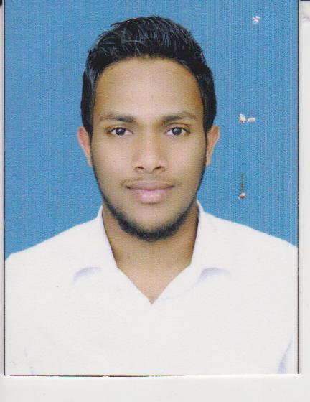
Mohamed
Matale | Sri Lanka.
Email : Mohamed.338386@2freemail.com

Professional Objective
To excel in my chosen career of professionalism while providing an effective and meaningful contribution for the enhancement of my organization.

Profile
Self motivated, committed, energetic, results oriented, hardworking in achieving the goals of the institution, and appreciate team effort.
Academic Qualifications :
- Passed G.C.E Ordinary Level (English medium)- 2009
- Passed G.C.E Advanced level (English medium) - 2012

Professional Qualifications :
Successfully completed,
- CIMA Certificate Level ( Fundamentals of Management Accounting | Financial Accounting | Business Mathematics | Business Economics and Fundamentals of Ethics | Corporate Governance and Business Law)
- CIMA Operational Level ( Financial Operation, management operation, Enterprise operation)
- IELTS examination with 5.0 overall
- Diploma in English
Computer Literacy :
- Diploma in computer Hardware
- High level proficiency in computer operations with extensive knowledge of Microsoft Word, Microsoft Excel, Microsoft Power Point and Microsoft Outlook.

Languages : English, Sinhala & Tamil
Basic knowledge in hindi.

Skills acquired whilst studying :
- Accepting feedback & taking constructive criticism well
- Able to develop & maintain good relationship with work colleagues and superior managers.
- Willingness to learn new things.
- Effective time management skills & able to prioritise tasks in order of importance.
- Willingness to share skills, knowledge & expertise

Key Competencies :
- Bringing good ideas into life
- Clear & informative written & verbal communication skills
- Ability to work quickly & effectively with little supervision
- Being alert to what is going on in the organization

Professional Experience :
- While studying CIMA, partly worked at forex exchange ( Royal money
Mart pvt ltd, Colombo ,Srilanka.—2013-2014)

Cashier/ Assistant Accountant ( January 2014 - December 2014)
(Jewellanka Money Exchange (Pvt Ltd) - Negombo, Srilanka)
Responsibilities Handled :
- Changing of currencies.
- Handling large amount of cash alone.
- Banking activities.
- Maintaining returned check accounts.
- Preparing monthly balance sheet.
- Accruals and prepayment.
- Making sales of jewelleries equipment.

Assistant Accountant / Administrator - 1 year
(Soft Bank (Pvt Ltd) - Matale, Srilanka)
Responsibilities Handled :
- Creating and revising systems and procedures by analyzing operating practices, record keeping system.
- Resolving administrative problems by coordinating preparation of reports.
- Handling incoming mails & other materials.
- Organizing internal & external events.
- Maintaining inventories.

***** Currently works at Emirates NBD outsource company in jabel ali (UAE) free zone visa . Working in the possition of document controller. (work started on jan 2016).

Responsibilities Handling :

- Maintaining the customers documents/files in a proper and confidential manner.
- Recording/scanning/verifying doing data entry by processing the customers documents/cheques in a safety manner through applications and excel.
- Handling the project named CAU/EMPOST.
- Doing photo copy and make arrange to move the customer’s document boxes.
- Refilling/PDT the files/documents using the barcodes.

Extra Curricular Activities :
- Sports played in school /district level – Cricket, Basketball, hockey and Football.
- Participated in athletes.
- Member of Interact Club and the department of Muslim religious & cultural affairs.
- Member of the school prefects’ board.

Personal Information:

- Full name: Mohamed

- Date of birth: 06th November 1993

- Religion: Islam

- Nationality: Sri Lankan

- Alma matter: Zahira National College – Matale
- Personal Interests: Travelling, Rugby and Cricket

I wish to take this opportunity express my desire to join your prestigious organization and to make a positive contribution. I certify that the above information is accurate for the best of my knowledge.

