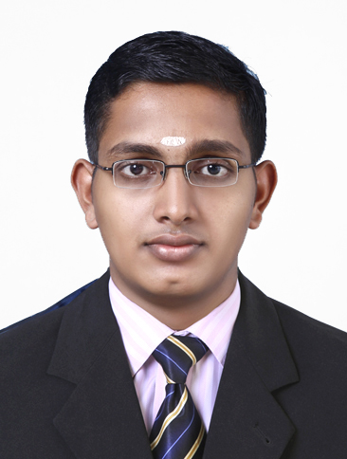  Personal Data  Date of Birth:  20.05.1991  Gender:  Male  Nationality:  Indian  Languages Known: English  Malayalam  Hindi  and Tamil | Curriculum vitae  AKHILESH  AKHILESH.338402@2freemail.com  Objective  To make a sound position in corporate world and work successfully in team to achieve goal of the organization/MNC with devotion and hard work  Presently working  • Store keeper “Calicut Paragon” Dubai, UAE (APR- 2014)  Order the food stuff, check the quality and distribute stuff to sections according to the order, Prepare the reports  Worked  - Worked in JUMEIRA ROTANA HOTEL,DUBAI, as storekeeper (2012 OCT-2013 MAY)  - Worked in LE’MERIDIEN, JAIPUR (2012feb-2012oct) as Buyer  - Trained at THE LEELA KEMPENSKI,KOVALAM, INDIA . In sales, marketing, and food and beverage.  My Strengths  GOOD LISTENER AND LEADERSHIP QUALITY  My Areas of Interest  Sales and Marketing  My Achievements  - Active participation in REGALO’10, a national level competition on hospitality management conducted at Nimit.  - Attended various ODC in Casino ,Taj , Leela ,Le’meridiean, Ramada  - HACCP certificate holder  Education  • Bachelor’s Degree in International Hospitality Administration (3 Years, 2009- 2012 )  • Higher Secondary (2006-2009)Board of higher secondary education  - SSLC(2005)General educational department  Skills & knowledge  - Knowledge about micros  - Knowledge about FBM  - Knowledge about Infrasys  - Knowledge about Hot soft  - Tally  Declaration  I hereby declare that all the information mentioned above is true to the best of my knowledge & Belief.  Date: 05/ Jan /2017  Place: DUBAI

