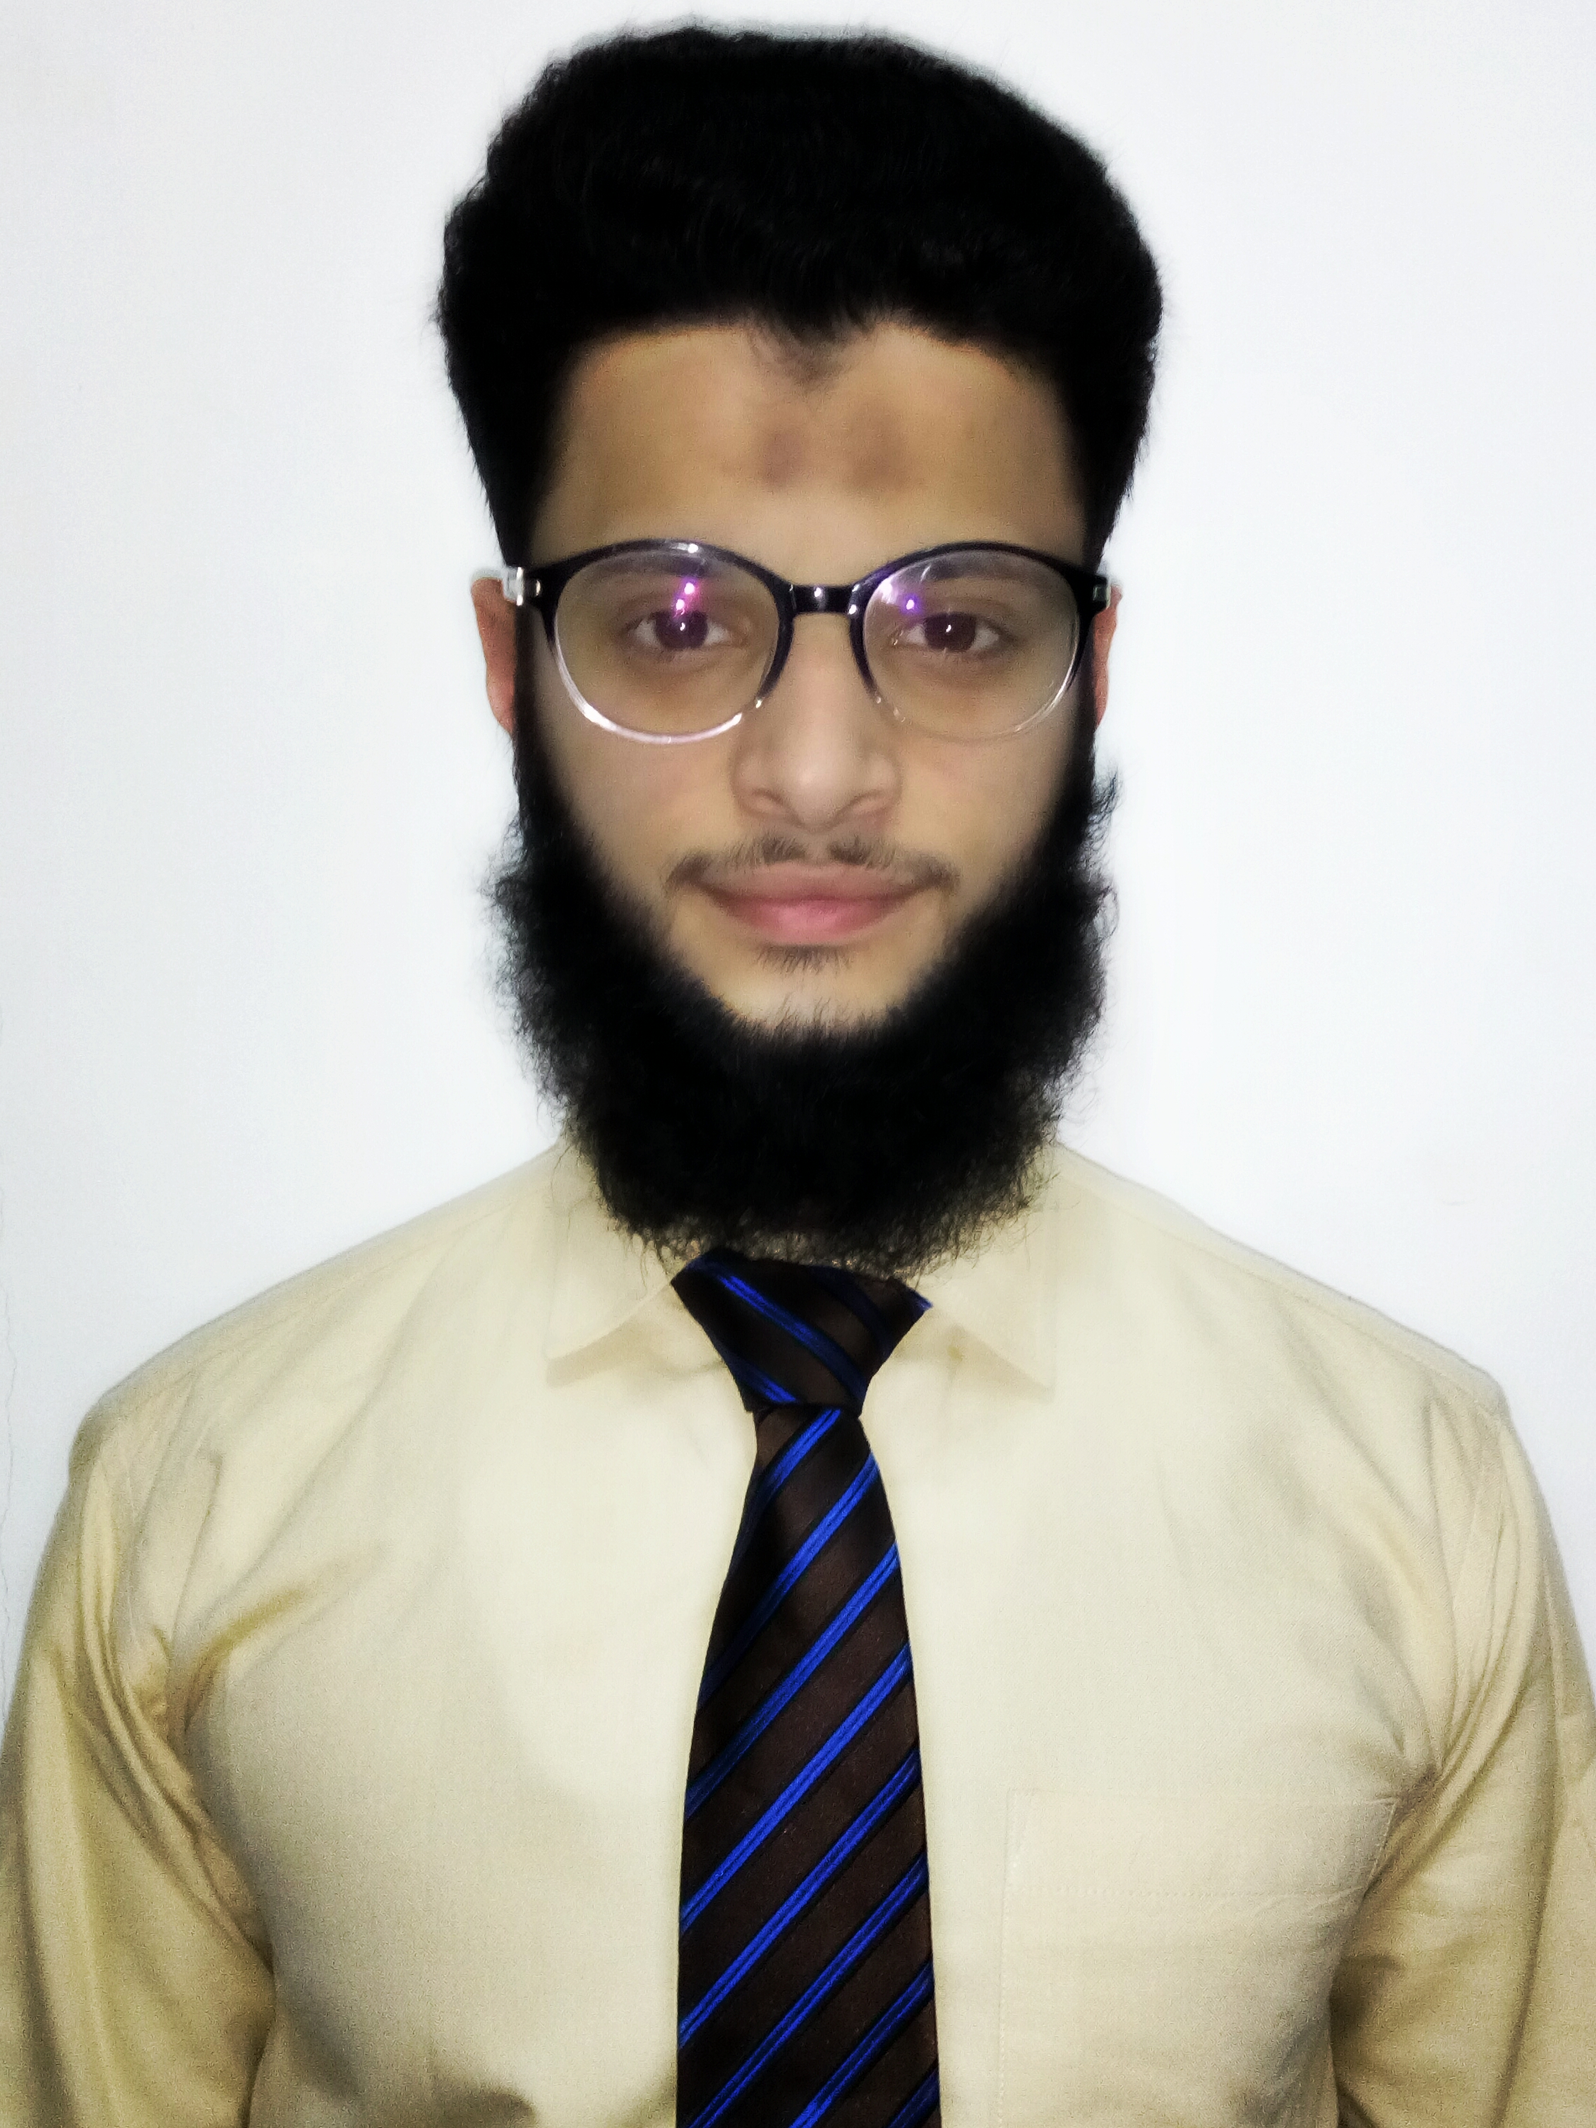
CURRICULUM VITAE
Ahsan
Email: Ahsan.338442@2freemail.com

PERSONAL INFORMATION
Date of Birth: 13th September 1993
Nationality: Pakistani
Religion: Islam
Marital Status: Single
Languages: English, Urdu

CAREER OBJECTIVE
To achieve professional excellence and obtain a position where my skills and talents can be utilized to their maximum potential and where challenges can diversify and expand my knowledge.

EXPERIENCE
CASH OFFICER – TAMEER MICROFINANCE BANK LTD. (21ST JUNE 2016 – 29TH DEC 2016)
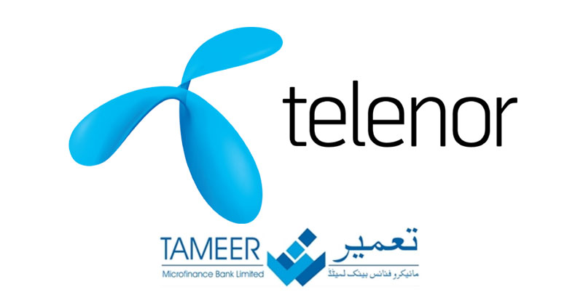
JOB DESCRIPTION:

- Receive deposits and making payments against cheques.
- Clearing of internal and external cheques.
- Receive Customer Utility Bills.
- Maintain Daily Transaction reports (DTL) with Operation Manager.
- Properly reconcile cash on daily basis.
- Receive Installments from loan customers.

ADMIN ASSISTANT – FIRST WOMEN BANK LIMITED. (MARCH 2013 – MARCH 2016)


- Work as Printing Machine operator under the contract
of SAAMI TRADING COMPANY.
- Perform several office boy duties as per instructions of
Head of Admin.

ACADEMIC QUALIFICATION

Description Year of Passing Current Status
- Bachelor of Commerce with 2nd division 2016 Completed
- Intermediate (commerce) with Grade B 2013 Completed
From Karachi Board.

- Matriculation (Science group) with Grade A 2011 Completed
From Karachi Board

EXTRA CURRICULUM ACTIVITIES AND CERTIFICATES RECEIVED
- Participation certificate in “Leader’s Expo 2013” One day Youth Leadership Conference of Asia.

- Participation certificate in Workshop on Islamic Banking held at Muhammad Ali Jinnah University in 2012.

- Certification in English language from “DOMINO LANGUAGE CENTRE“ in 2016.

COMPUTER LITERACYSS
- MS WORD
- MS EXCEL
- MS POWER POINT
- WINDOWS MOVIE MAKER
- INTERNET

SKILLS AND ABILITIES
- Self-motivated,
- Committed and Adaptive
- Hard worker
- Competitive
- Confident

HOBBIES AND INTREST
- Reading
- Photo Editing
- Poetry

Reference: To be furnished upon request

