Mark
Email :- Mark.338471@2freemail.com

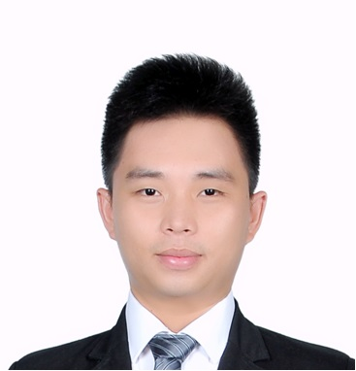
Employment History
Mar 2014 - Sep 2015 | Sales and Customer Service Supervisor  Caesars Entertainment Casino and Hotels  Teleperformance | Philippines
 | Industry |  |  | Hospitality
 | Specialization |  |  | Sales - Reservation/Telemarketing
 | Position Level |  |  | Junior Executive
 | Job Description: Responsible for the overall performance of the team. Manage the team by making sure that the attendance and other client’s metrics and goals required are met. Assists and support representatives with any challenges in processing reservation and sales. Handle coaching and training to representative enhancing their product knowledge and new company updates. Generating performance reports for the management and the Clients. Presenting the reports of performance, action plans and new strategies to increase the sales and revenue.
Sep 2013 - Feb 2014 | Hospitality Consultant and Sales Representative  Expedia Incorporated and Travelocity Corporation  Aegis People Support | Philippines
 | Industry |  |  | BPO/ Hospitality
 | Specialization |  |  | Hotel Management/Tourism Services
 | Position Level |  |  | Non Executive
 | Job Description: Assisting clients booking their flight, accommodation and tours. Educate clients of the documents needed upon travel. Collecting and processing payments. Keeping up to date with any changes and assists clients rearrange their itineraries if needed. Dealing out with complaints and refunds.
Aug 2011 - Aug 2012 | Housekeeping Coordinator  Hyatt Regency Kinabalu | Sabah, Malaysia
 | Industry |  |  | Hotel / Hospitality
 | Specialization |  |  | Hotel Management/Tourism Services
 | Position Level |  |  | Non-Executive
 | Job Description: Responsible for the daily coordination of housekeeping operation. Accountable for ensuring the departments achieves the highest level of service delivery through effective communication and follow up. Receiving calls from guest for any request from housekeeping. Communicating with front office department, housemaids, runners, housekeeping supervisors for the room status and updates and other request to achieve smooth operation in the department.
Oct 2009 - Aug 2011 | Food and Beverage Attendant /Team Leader  The Place Office Pub | Malaysia
 | Industry |  |  | Food & Beverage / Catering / Restaurant
 | Specialization |  |  | Food/Beverage/Restaurant Service
 | Position Level |  |  | Non-Executive
Job Description: Greets Customers and presents them with the menu. Informs customers about the special items for the day and menu changes if any. Suggest food and beverages to the customers and also try to up-sell. Take food and beverage orders from the customers on the order taking pads or on the handheld Point of sale system.
Punch the order on the POS machine and make sure to enter the special requirements made by the customers while ordering the food. Prepare and serve alcoholic and non-alcoholic drinks to customers. Communicate to the customers and provide assistance with their concerns. Server food and beverage to the customers as per the course of order. Observes guests and ensure their satisfaction with the food and service. Close the shift on the POS terminal.
Education
May 2009- Jun 2012 | Asian Tourism International College  Diploma in Hotel Management | Malaysia
 | Major |  |  | Hospitality Management
Skills
Intermediate |  |  | Microsoft Excel, Microsoft Word, Microsoft PowerPoint
Basic |  |  | Sabre Global Distribution System, Opera
Intermediate |  |  | Driving Skills, Art Crafts
Languages
Proficiency level: 0 - Poor, 10 - Excellent
Language | Spoken Written
English | 9 8
Filipino (Primary) | 10 10
Bahasa Malaysia | 8 5
Personal Information

Gender: |  | Male |  |  | Height: | 175 cm
Age : |  | 24 years old |  |  | Weight: | 75 kilogram
Nationality |  | Filipino |  |  | BMI: | 24.4 (Normal)

