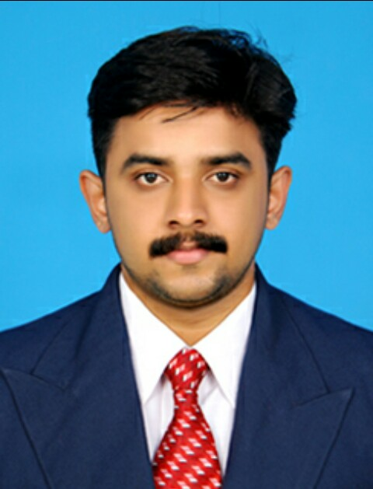
CURRICULUM VITAE

PERSONAL DETAILS : ABILASH
ABILASH.338530@2freemail.com

OBJECTIVE:
Seeking a challenging job position to use my problem solving, and hard working skills for the mutual growth.

EXPERIENCE:
1 year experience as a marketing Executive in REGMA CERAMICS Limited,Karaikal,Pondicherry (2012-2013)
1year experience in srivatsa MARUTI SUZUKI, Nagercoil as a sales executive.
(JANUARY 05 2015 –JANUARY 17 2016)
1 year experience in ICICI PRUDENTIAL LIFE INSURANCE ,Nagercoil as a UNIT MANAGER (from Feb 04 2016 – Jan 13 2017)

PROJECTS:

INTERNSHIP MINI PROJECT: Organization : Regma Ceramics Tiles industry,Karaikal,PONDICHERRY
Title : Organisational Studies
Duration :45 Days
FINAL PROJECT :
Title : Analysing customer satisfaction of SAMSUNG Refrigirator in CHENNAI
Duration: 60Days
KEY STRENGTHS:
- Results oriented
- Excellent Communication and People skills
- Analytical and Problem Solver

PERSONAL CHARATERISTICS:
- Team Player :Dedicative
- Decision Making Skills
- Positive Attitude and Good Sense of Humour
- Able to Work Independently:Self- Disciplined

ACADEMIC QUALIFICATION
- MBA srm University
Aggregate CGPA:8.01%
- B.Sc. Physical Education
Scott Christian College,Nagercoil.
Aggregate CGPA: 7.01
- 12th Board
Government HSS.Thuckalay.
Aggregate Percentage: 56%
- 10th SSLC
St.MarryGorettyHSS.Manlikarai.
Aggregate Percentage: 65%

ADDITIONAL QUALIFICATION:

- PG Diploma in YOGA

EXTRACURRICULAR ACTIVITIES:
.
- Pencil Art,singing,Mimicry
- Ability to teach YOGA

LANGUAGE SKILLS:
-
- English
- Tamil
- Malayalam

Personal information

DATE OF BIRTH :14.06.1990
SEX :Male.
NATIONALITY :Indian.
MARITAL STATUS :Single

DECLARATION
I do here by declare that particulars of information and facts stated here in above are true, correct and complete to the best of my knowledge and belief.

