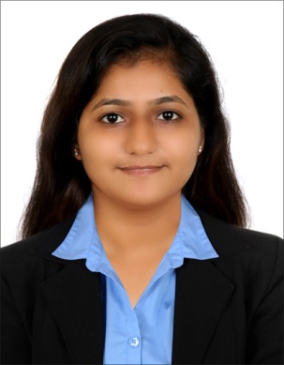
JETHWA
JETHWA.338535@2freemail.com

• Well organized self-starter with proven capacity to learn and apply new knowledge quickly.
• Native Gujarati speaker with additional language proficiencies that includes fluency in English and Hindi.

TECHNICAL SKILLS
- Operating Systems: Windows 7, Windows XP. Programming
- Languages: C#, VB. Databases : Ms-Access,Ms Sql Server, My Sql.
- Packages: MS Office.
- Web Technologies: HTML, ASP.

EXPERIENCE
- Coaching tally
- Handling incoming and outgoing communications
- Organizing and updating the system
- Gives assistance and explain every detail of the lesson

- Coaching DPS School
- Guiding the children of the proper
- Assist the teacher in making the lesson plan
- Keeps a schedule of activities

- Job in IDBI Bank in Rajkot
Customer service

- Assist client with the requirements needed
- Handling incoming and outgoing communications
- Ensure an orderly queue7

- Sinter Company India
- DEO Data Operator in maintenance department

- Delmont Trading company l l c
-RECEPTIONIST June 2015
- Working within a reception environment providing a telephone answering, admin
And reception service as well as organizing the post, welcoming visitors and
Providing hospitality towards guests and clients.

EDUCATIONAL BACKGROUND

M.sc.(I.T&C.A)
M.sc.IT 1 sem., Jan 2010, Saurashtra University – Dr.V.R.G College Porbandar.
Marks Obtain:-58.43%
M.sc.IT 2 sem., May 2010, Saurashtra University – Dr.V.R.G College Porbandar.
Marks Obtain:-63.69%
M.sc.IT 3 sem., Nov 2010,Saurashtra University – Dr.V.R.G College Porbandar.
Marks Obtain: 68.05%
M.sc.IT 4 sem., April 2010, Saurashtra University – Dr.V.R.G College Porbandar.
Marks Obtain:-70.84%
P.G.D.C.A
P.G.D.C.A . 1 Sem., Nov 2008, Saurashtra University – J.K.Ram College Veraval.
Marks Obtain:-43.40%
P.G.D.C.A . 2 Sem., May 2009, Saurashtra University – J.K.Ram College Veraval.
Marks Obtain:-53.80%
B.Com
T.Y.B.Com Mar 2008,Saurashtra University-Matru Shree Manuben Arts&Commarce
College, Sutrapada. Marks Obtain:-71.57%

H.S.C
H.S.C, Mar 2005, G.S.H.E.B - V.V.Mandir, Sutrapada. Marks Obtain:-67.83%

S.S.C
S.S.C, Mar 2003 G.S.E.B.- V.V.Mandir, Sutrapada. Marks Obtain:-59.29%

Personal Data:

Nationality: Indian

