Gonagala Withanage Anushka
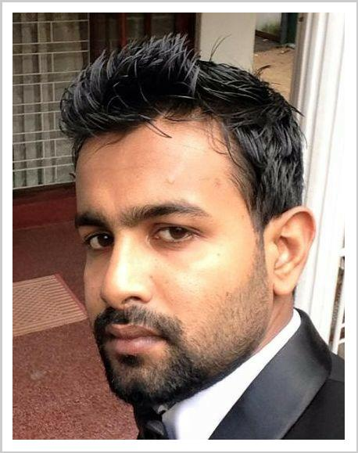
Assistant manager

current location:Dubai

E-mail gonagala.338558@2freemail.com 1/18,Mahamegaramaya

Marital status single

Date of birth 1992-03-22

Place of birth kaluthara

Started with the designation of Accounts Assistant at Premadasas Gems and Jewellery (pvt) ltd. within first year at the company i was appointed as the Gem stock and Handicraft stock assistant with the salary increment. further top mangement of the company decided to allow me to pay in commission according to my performance.
 | Experience
2013-12 - 2016-12 | Sales executive
 | No, 79 Darmapala mawatha , Colombo 07.sri lanka
 | Post of Account Assistant- Effect from 01st december 2013 up to 19st december 2015 at M/S. Premadasa Gems
 | &
 | Jewelery.(part time)
2016-10 - 2016-12 | Assistant manager
 | No, 79 Darmapala mawatha , Colombo 07.sri lanka
 | Post of Assistant manager- Effect from 01st february 2016 up to today at M/S. Premadasa Gems &
 | Jewelery.
2015-03 - 2016-01 | Gem stock and Handicraft stock assistant
 | No, 79 Darmapala mawatha , Colombo 07.sri lanka
 | Post of Gem stock and Handicraft stock assistant- Effect from 01st march 2015 up to 01st january 2016 at M/S.
 | Premadasa Gems &
 | Jewelery.
2014-01 - 2015-02 | Assistant cashier
 | No, 79 Darmapala mawatha , Colombo 07.sri lanka
 | Post of Assistant cashier - Effect from 01st january 2014 up to 01st february 2015 at M/S. Premadasa Gems &
 | Jewelery.
2013-10 - 2015-04 | Accounts Assistant
 | No, 79 Darmapala mawatha , Colombo 07.sri lanka
 | Post of Account Assistant- Effect from 01st October 2013 up to 01st february 2015 at M/S. Premadasa Gems &
 | Jewelery.
 | Education
1998 - 2008-12 | Royal college Monaragala
 | G. C. E. (O/L) EXAMINATION
 | E.N. - 82501165
2010-10 - 2012-07 | Royal college Monaragala
 | E.N.- 6016774 – Commerce Stream
 | G. C. E. (A/L) EXAMINTION
2011-10 - 2012-12 | Esoft Studies (pvt)Ltd

Completed Diploma in English Language

2011-07 - 2012 Esoft Studies (pvt)Ltd

Completed Diploma in Business Management

2012-01 - 2012-12 Esoft Studies (pvt)Ltd

Completed Diploma in Computerized Accounting

Skills

telephone etiquettes computer literacy
Supportive & good in Hospitality
Patient, Pleasant & Respect others
Ethical
Polite & Courteous
Languages

English
chinese
Certificates

Education Department inter school-Won 1st place for high jump under 18 years 2008 – Uva Province.

Certificate for participation future leadership skill development and reconciliation

Certificate for participation future leader ship skill development

Member of College Cadet Cope/Eastern Musical Band

Sri Lanka Red Cross Society-Certificate for Disaster Training Volunteers

Licenses

2012 Posses Valid Driving Licnece for all Vehicles (international)

