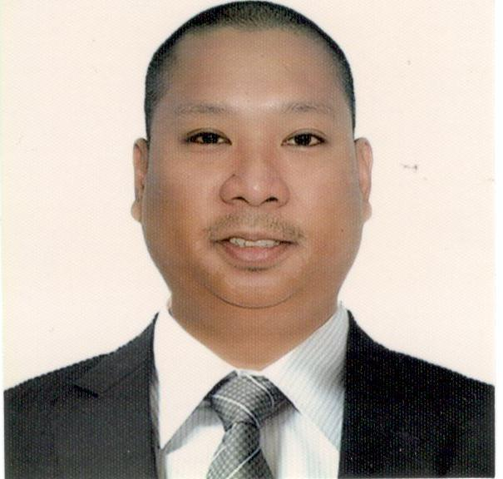
RONALD
RONALD.338574@2freemail.com

Career Objective
To be employed by an organization that will utilize and enhance my administrative, secretarial, customer service and management skills.
Profile
An independent, dedicated, focused and self-motivated professional with a solid work ethics; able to prioritize and complete multiple tasks and follow through to achieve project goals; able to grow positive relationships with multi-cultural clients and colleagues at all organizational levels

Key Skills
Customer Service Office Management
Sales Coordination and Management Event Planning and Organizing
Report Generation Meeting and Travel Support
Team Building Networking and Troubleshooting

Computer and Software Knowledge
- Well versed in MS Office Applications ( such as MS Word, Excel, Powerpoint, Outlook)
- Microsoft Windows and MAC OSX

Work Experience

Admin Assistant (May 2012 – November 2016)
RTC Financing Corporation
Santiago City, Philippines

Responsibilities include:
- Manage the reception area and all its functions
- Screen incoming calls and mails
- Handle petty cash
- Manage conference meetings for executives (venue, attendees, refreshments, etc.)
- Act as an over-all office administrator and multi-task between admin and secretarial role to the GM and sales department
- Maintain filing system
- Encode database and account related documents
- Monitor appropriate use of office supplies and manage inventory
- Respond to inquiries and provide office support as needed
- Manage repair and maintenance of office equipment
- Ensure cleanliness of the front desk at all times

IT Support (May 2008 – May 2012)
Merle Auto & Industrial Supplies
Manila Philippines

Responsibilities include:
- Installation and maintenance of company’s computer systems and network
- Perform upgrades and installed updates
- Troubleshoot and repair when computer had problems
- Assist office staff with computer applications questions
- Recommend computer products and applications to improve productivity

Education
Bachelor of Science in Computer Science
AMA Computer College, Philippines
Year Graduated: March 2004

Personal Information

Date of Birth: November 12, 1983
Marital Status: Single
Languages Spoken: English (Professional), Tagalog (Mother Tongue)
Visa: Tourist visa, valid until March 5, 2017
Availability: Immediately

References: Available upon request

