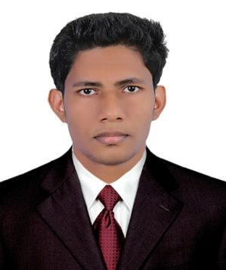
RESUME

JINESH
JINESH.338577@2freemail.com

OBJECTIVE

Seeking a challenging position in an organization as an incentive to learn and work smart to achieve success and acquire the richness and variety of experience as I move ahead. To dedicate maximum to the profession with commitment and devotion, in order to prove my worth.

ACADEMIC QUALIFICATION
Course | Institution | Board | Year of completion | Marks%
MCA | Shree Devi Institute of Technology,  Mangalore. | Visvesvaraya Technological University | 2014 | 64
BCA | Pilathara co-operative Arts and Science college,  Kannur. | Kannur  University | 2011 | 63
XII | Government boys Higher Secondary School,  Madayi | Kerala State Board | 2008 | 70
X | Government Higher  Secondary School,  Kunhimangalam.. | Kerala State Board | 2006 | 82

AREAS OF INTEREST

- Object Oriented Programming Languages.

SKILL SET

- Languages : C, C++,java,PHP.
- Web Technologies : HTML,CSS, CodeIgniter.wordpress.
- Backend : MYSQL.
- Web Designing : Photoshop.
- Platforms : Windows 7/8/2000/XP/Vista, ubuntu, redhat.

PROJECT WORK (ACADEMIC)

- “Online Tourism Management” as a minor project developed for User by using PHP as front end and MYSQL as back end during the final year of BCA.
.
- “Online Banking System” as a major project developed for User by using PHP as front end and MYSQL as back end during the final year of MCA.

ACHIEVEMENTS AND POSITIONS HELD
- Team member for events gaming and cultural in MEDHA, a national level technical fest held in SDIT..

STRENGTH
- Able to adapt with dynamic Environment.
- Good communication Skill.
- Able to work well in a team or independently.
- Have excellent leadership and pioneering qualities.

PERSONAL PARTICULARS

Date of Birth : 13.02.1991
Nationality : Indian
Languages Known : English, Malayalam, and Hindi.

HOBBIES& INTERESTS

- Coin collection
- Watching Sports
- Surfing

EXPERIENCE

- 2 years of experience as a junior web developer at Wiztelsys Server Technologies kochi,India.
Responsibilities: Developing websites using HTML, CSS , PHP,MYSQL,Wordpress.
Helping to encode the project .
Agreeing proposals .
Writing new software and operating manuals .
Testing the product to ensure that it operates satisfactorily .
Handling support and feedback.
DECLARATION

I, Jinesh. hereby declare that all the details furnished above are true to the best of my knowledge.

