CV No 2031528
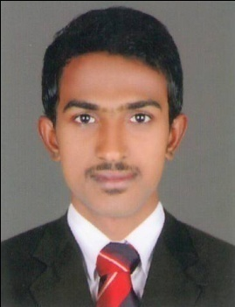
sefeer.n.k

___________ _OBJECTIVES__________________________
_____________________________________________________________________________________________

To attain a respectable position in a fast growing and reputed organization and to become an invaluable asset to the same and to become a standing example for all, in areas of learning, growth and everything else possible.

______________________________PROFESSIONAL SKILLS____________________________
- Hard working , relatable with a proven ability to deliver high quality work
- Progressively responsible duties resulting from exceptional performance and a strong commitment
- Proven ability to gather, extract and use data effectively
- Excellent interpersonal skills.
- Good communication skill
- Self confident and poised in interaction with individuals at all level readily developing report with seniors and colleagues.
- I have strong desired to succeed

___________________________ PROFESSIONALEXPERIANCE __________________________

- Logistic / Documentation Executive in Shipping Department

Key Functions

- Handle Export & Import Documentation.
- Provide Freight Quotation to individual customers through email.
- Get booking confirmation & provide container release letter.
- Customer canvassing
- Customs Inspection & Clearing.
- Well known about Mirsal-II
- Well know about Dubai Municipality online clearance. (FIRS, Label Approval, Health Certificate & Certificate of Origin

______________ _EXTRA CURRICULAR ACTIVITES_______________________________

- Listening to news, music
- Helping others
- Free time spend with friends
- Traveling.
- Driving

_________________COMPUTER KNOWLEDGE________________________

- Windows2007 MSWord, Powerpoint , MSOffice,

__________________EDUCATIONAL CREDENTIALS_________________________

- I Have Completed My DIPLOMA IN LOGISTICS & SUPPLY CHAIN MANAGEMENT in 2012-2013 at PG Academy, Ernamkulam

- B com Graduate from MS University in 2013-2015

- +2 COMMERCE FROM HIGHER SECONDARY EDUCATION IN KERALA.2010-2012

___________________PERSONAL DETAILS_____________________________

Nationality : Indian (M0174572)

Languages : English/ Malayalam

Date of Birth : 23 April 1993

Marital Status : Single

Visa Status : Work Visa (willing to Join Immediately)

License : Vailed uae and indian driving license

DECLARATIONS ____________________________
The truthfulness of the details furnished above is assured to the best of my knowledge and
belief.

SEFEER.N K– CV No 2031528

To interview this candidate, please send your company name, vacancy and salary offered details along with this or other CV Reference Numbers that you may have short listed from
http://www.gulfjobseeker.com/employer/cvdatabasepaid.php
addressing to HR Consultant on cvcontacts@gulfjobseekers.com

We will contact the candidates to ensure their availability for your vacancy and send you our service HR Consulting Fees quotation for your approval. Whatsapp +971504753686

______________________________________

