RESUME

KAUSELYA
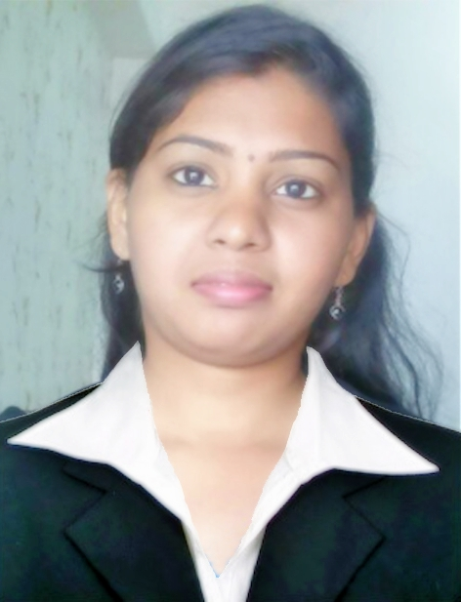
Dubai
(Visit Visa) E-mail: KAUSELYA.338632@2freemail.com

Objective
To be involved in work where I can utilize skill and creatively involved with system that effectively contributes to the growth of organization.
Work Experience (2+ Years)
- QIC (Qatar Insurance Company, India)
Worked as a HR Executive / Office Administrater from (June-2016 to December-2016)
Duties and Responsibilities :
- Answering employee questions
- Creating and distributing documents
- Providing customer service to organization employees
- Serving as a point of contact with benefit vendors/administrators
- Setting appointments and arranging meetings
- Maintaining calendars of HR management team
- Compiling reports and spreadsheets and preparing spreadsheets
- Identify criteria needed for the job & gathering candidates through the usage of available resources internally and externally
    - Screening of Resumes.
    - Calling candidates.
    - Interview Scheduling.
    - Maintaining Proper Database for each Employee

- Sky Engineering (ISO 9001 Certified company) Chennai, India
Worked as a HR Executive / Office Administration from (May-2014 to June -2016)
Duties and Responsibilities :
- Updating and maintaining employee benefits, employment status, and similar records
- Maintaining records related to grievances, performance reviews, and disciplinary action
- Performing file audits to ensure that all required employee documentation is collected and maintained
- Performing payroll/benefit-related reconciliations
- Performing payroll and benefits audits and recommending any correction action
Completing termination paperwork and assisting with exist interviews
- Maintenance the Accounts details

Core Competencies
- Sound knowledge of HR workings.
- Good command over HR concepts.
- Familiar with working of Ms Excel.
- Problem solving skills.
- Can work under pressure.
- Target oriented.

Position Served

- Office Receptionist , Secretary
- Accounts
- HR
- Administrator
- Customer Support

Qualification
April 2014 - MBA Finance and HR Sathyabama University, Chennai, India (CGPA: 80)
April 2012- BE Computer Science and Engineering Rajalakshmi Engineering College, Chennai -Tamil Nadu, India (CGPA: 75.57)
April 2008-XII Standard, Sri Vidhya Mandir Higher Secondary School, Uthangarai -Tamil Nadu , India -Marks: 1019/1200(82.63%)
April 2006-X Standard, Lions Matriculation Higher Secondary School, Tirupattur-Tamil Nadu , India -Marks: 909/1100(84.91%)
Technical Expertise
- Microsoft Office, Outlook , Tally ERP 9
Personal Skills
- Ability to move with people easily.
- Willingness to learn quickly and work hard.
- Ability to work as a team.

Under-Graduate Project
- Identification of Centroblasts using image analysis.

Post-Graduate Project
- Effectiveness Of Internet Banking in Indian Bank, Chennai..
Co-Curricular / Extra Curricular Activities
- Acted as School Pupil leader during my School days.

- Represented my school in district level Shuttle competitions during my school days.

- Active member of Rotract Club at Rajalakshmi Engineering College.

- Class Topper in 1st and 2nd Semester exam in Sathyabama University.

- Actively Participated in Entrepreneurship Awareness Camp at Sathyabama University.

PERSONAL INFORMATION:
Date of Birth : 06th December 1990
Sex / Marital Status : Female / Married
National / Religion : Indian / Hindu
Expiry Date : 02/06/2026
Languages Known : Tamil, Hindhi & English

I, KAUSELYA do confirm that the information given above is true to the best of my knowledge.
Place : Karama (Dubai)
Date : SIGNATURE

