CV No 2031870

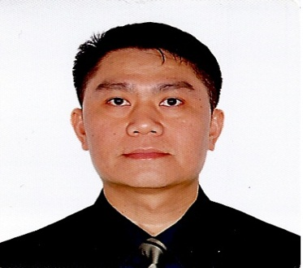
MICHAEL

_________________________________________________________________

Objective:

To be a part of an organization where I can share my knowledge and utilize my skills to contribute in the company’s growth and prosperity.

Area of Expertise:

- Coordinator
- Supervisor
- Administration Staff
- Receptionist
- Sales Personnel

Profile Summary:

- Energetic and Enthusiastic with refined manners.
- Can work under pressure,meet deadlines and with less supervision.
- Self-motivated and ambition with strong desire to succeed.

Knowledge & Skills:

- Can communicate well to client, attend issues and concerns
- Can do planning to update and upgrade the operations procedures
- Can supervise subordinate, personnels and colleague regarding work.
- Computer knowledge MS Office Packages Internet and Email.
- Knowledge in documentations and fillings of private & government transactions.
- Had wide knowledge regarding sales operations,planning and documentations.
- Had wide knowledge in Safety and Security procedures.
- Knowledge in driving manual & automatic transmission.
- Knowledge in CCTV operation and procedures.

Work Experiences:

Receptionist
September 1,2015 up to present

Administration Support ( Emirates Aluminium Badging Unit) EMAL Abu Dhabi
February 2015 up to August 2015

Administration Staff Main Risk Control Center, St. Regis Hotel Abu Dhabi
May 2013 up to January 2014

Administration Staff
Emerson Electric Asia Ltd. Regional HQ
April 2009 up to May 2013

Supervisor Booking Salesman
Phillip Morris / Marlboro Cigarette
October 2008-April 2009

Supervisor Van Salesman
Distributor of Pepsi Cola Products
August 2008-September 2008

Educational Background:

Secondary Torres High School
1986-1990

Tertiary Baliuag State University
1990
Bachelor of Science Electronic Communication Engineer (Undergradute)

Seminars and Trainings:

Basic Safety Course Philippine Marine Training Institute

Basic Salesmanship Olongapo City

Handling Confidential Information First Sumiden Circuits Incorporated

First Aid Training Emerson Electric Asia Ltd. ROHQ

Basic Life Support Emerson Electric Asia Ltd. ROHQ

Telephone Courtesy Emerson Electric Asia Ltd. ROHQ

Customer Service Emerson Electric Asia Ltd. ROHQ

Basic Fire Fighting Emerson Electric Asia Ltd. ROHQ

Emergency Response Bomb Threat Emerson Electric Asia Ltd. ROHQ

Safety Leadership Skills Emerson Electric Asia Ltd. ROHQ

Personal Information
Name : Michael Ramos Quirabu
Date of Birth : April 23,1973
Nationality : Filipino
Marital Status : Married

Declaration

I hereby certify that the above informations given are true and correct to
the best of my knowledge.

Michael R. Quirabu

Michael R. Quirabu – CV No 2031870

To interview this candidate, please send your company name, vacancy and salary offered details along with this or other CV Reference Numbers that you may have short listed from
http://www.gulfjobseeker.com/employer/cvdatabasepaid.php
addressing to HR Consultant on cvcontacts@gulfjobseekers.com

We will contact the candidates to ensure their availability for your vacancy and send you our service HR Consulting Fees quotation for your approval. Whatsapp +971504753686

______________________________________

