**Resume**

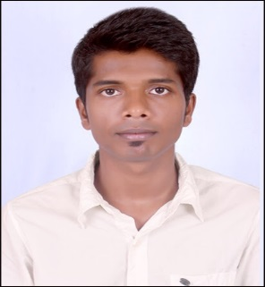

**Kushal**

[**Kushal.338649@2freemail.com**](mailto:Kushal.338649@2freemail.com)

**Objective**

To succeed in an environment of growth and excellence and earn a job which provides me satisfaction and self development and help me to achieve organizational goal.

**Educational/Professional Qualification**

|  |  |  |  |  |
| --- | --- | --- | --- | --- |
| **University/Board** | **Institution** | **Degree** | **Year of Passing** | **Percentage** |
| Mumbai University | St. Gonsalo Garcia College | T.Y.B.Com | 2010-2011 | 55.00% |
| Maharashtra State Board | New English Junior College | S.Y.J.C. | 2007-2008 | 56.17% |
| Maharashtra State Board | St. Xavier’s High School | S.S.C | 2005-2006 | 54.00% |

**Certifications**

* Maharashtra State Certificate Information Technology (MS-CIT)
* Basic in Computers

**Work Experience**

I’ve worked with **WNS Global Services Private Limited** as an **“Associate”** in operations from **December 2011** to **August 2013**.

**Company Name & Responsibilities:** The British Gas Trading Limited

* Resolving/replying customers complaints and enquiries via calls, email & chats
* Preparing reports on a daily basis which is required (i.e. Daily clearance, IT Downtime etc)
* Reporting to managers on a daily basis

**Good knowledge of applications**

* SAP – ERP
* Siebel Energy

**2nd Job Work Experience**

I’ve worked with **Powerweave Software Services Pvt Ltd** as a **Back office executive** since **April 2014** to **December 2014.**

**Process Name & Work Responsibilities:** Hub - Pens

* Placing an Orders for the customers
* Handling Web Chats and emails of the customers of their issues
* Reporting to Manager on a daily basis

**3rd Job Work Experience**

I’ve worked with **Bigtree Entertainment Pvt Ltd** as a **Back Office Executive** since **July 2015** to **January 31st 2016**.

**Process Name:** Bookmyshow

* Handling customer’s complaints and queries via Chat/Email/Calls
* Helping New Joiners for better Process/Product knowledge

**4thJob Work Experience**

I’ve worked with **Kotak Life Insurance** as a **Sr. Associate** in **Grievance Department** since **February 2016 to August 2016.**

**Department name:** Grievance/Complaints

* Investigating the issues of the clients to give them a final resolution
* Handling escalation Calls/Chats/Emails
* Reporting to Senior Manager on a daily basis
* Taking sessions on the required topics

**Personal Details**

Date of Birth: 6th May 1991

Marital Status: Single

Religion: Hindu

Gender: Male

Nationality: Indian

Languages known: English, Marathi, Hindi and Kannada

Hobbies: Motorcycling

**I declare that the information given above is true to the best of my knowledge.**