Biomedical Scientist in Molecular and Cellular Biology
Suliman
Suliman.338664@2freemail.com
Nationality: French citizenship

Education and Degrees
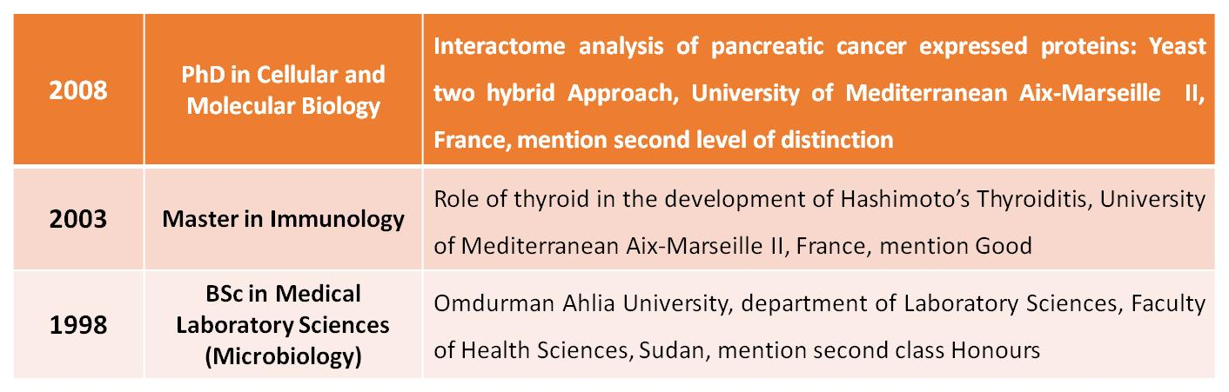
Professional Experience
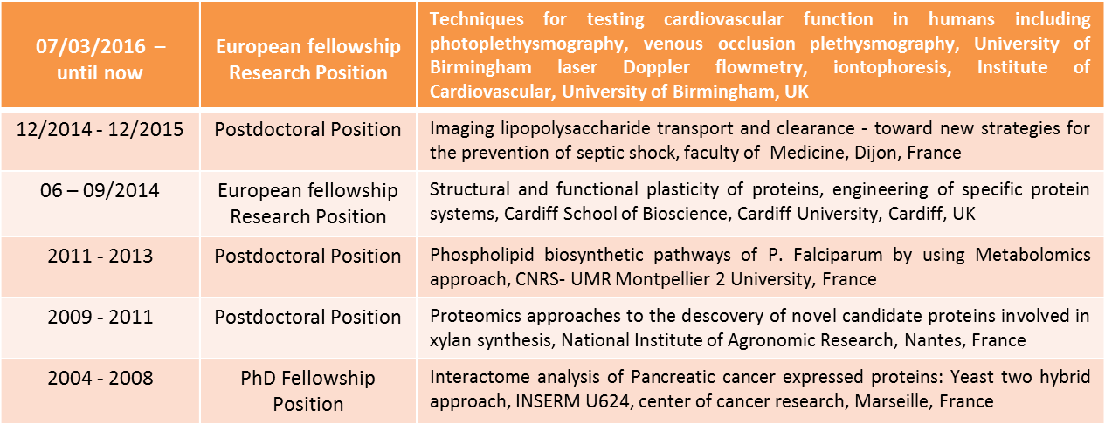
Publications
1- M. Suliman, T. Gautier, L. Lagrost. Explore the dynamic pathways involved in the detoxication of lipopolysaccharides by host organisms, the involvement of the circulating HDL. In preparation
2- M. Suliman, P. Wincker, T. Gautier, L. Lagrost. Effect of LPS detoxication to HDL and LDL can influence the different steps of pathway by Single-Molecule Dynamics and FRET/FLIM. In preparation
3-M. Suliman, AL. Chateigner-Boutin, M. Allami, A.Partier, B. Bouchet, J. Marrion, H. Rogniaux, D. Tessier, J. Salse, F. Guillon, C. Larré. Identification of glycosyltransferases involved in cell wall synthesis of wheat endosperm. J of Proteomics, 2012 Nov; (12)00716-6
4- AL. Chateigner-Boutin, M. Suliman, B. Bouchet, C. Alvarado, H. Rogniaux, F. Guillon, and C. Larré. Endomembrane proteomics revealed putative enzymes involved in cell wall metabolism in wheat grain outer layers. J Exp Bot. 2015 Mar 13
5-Subhash Thalappilly, MuhtadiSuliman, OdileGayet, Philippe Soubeyran, AurélieHermant, Patrick Lecine, Juan L. Iovanna and Nelson J. Dusetti. Interactome analysis of pancreatic cancer expressed multi-SH3 domain-containing proteins: A Yeast Two Hybrid Approach. Proteomics, 2008 Aug; 8(15):3071-81
6-J Roignot, D Taïeb, M Suliman, F André, NJ Dusetti, JL Iovanna and P Soubeyran. CIP4 is a new ArgBP2 interacting protein that modulates the ArgBP2 mediated control of WAVE1 phosphorylation and cancer cell migration. Cancer Lett. 2010 Feb 1; 288(1):116-23. Epub 2009 Jul 23
Chapters in Books
1- Written book on 'Pancreatic cancer' called "Role of Adaptor Proteins in Pancreatic Cancer", published 2014 - LAP LAMBERT Academic Publishing, ISBN 978-3-659-54506-1
Foreign language and computer skills
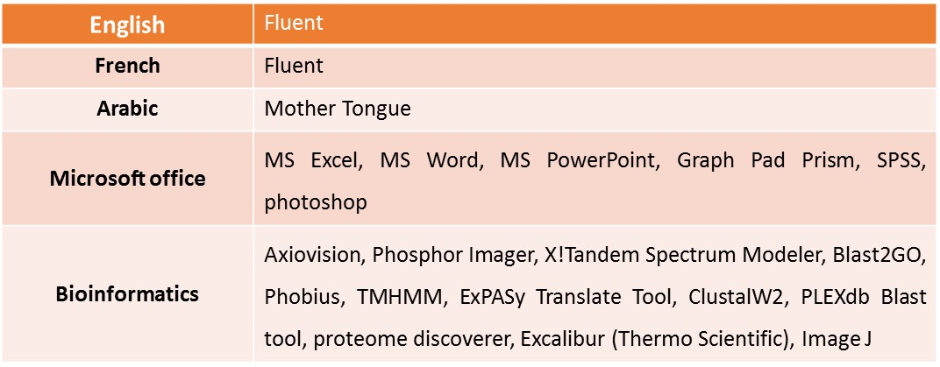
Conferences and workshops: invited speaker/participant
- June 2015/ Refinement workshop in animal experiments / Dijon; France
- February 2014/Quantitative metabolomic workshop/ Toulouse; France

- July 2012/ Infectiopôle Sud Day 2012/ Marseille; France

- September 2010/Congress French Society for Electrophoresis and Proteomics Analysis (SFEAP) / Marseille; France

- June 2010 / Young Researchers Day BIA 2010/Nantes; France

- June 2010 / The 9th day training Network of Centers Common Microscopy (RCCM) / Nantes; France

- June 2008/ Young PhD studentsday/Aix-Marseille University/Marseille; France

- June 2007/ Young PhD studentsday/Aix-Marseille University/Marseille; France

- October 2005 / Congress of French Pancreas Club /Monaco; France
Professional Society Memberships
- Danish Diabetes Academy (2016- present)

- French Society for Electrophoresis and Proteomics Analysis (SFEAP) (2009- present)

- Dutch Society for Mass Spectrometry (2012- present)

- French Society for Cellular Biology (sbcf) (2009- present)

- French network of Metabolomics (RFMF) (2011-2015)
Science teaching and outreach
I have supervised several students during their training periods or graduation (MSc) projects:

2016 Mentoring of postgraduate student project (Kyriakos Tsitoglou, PhD Student Clin & Experimental Medicine)
2011 Mentoring of undergraduate student project (Gabrielle Leroux, BTS)
2010 Mentoring of postgraduate student project (Sandrine TCHOA KWETCHA, MSc)
2005/2008 Mentoring technician and research assistant in INSERM U624, France
1998/2002 Teaching assistant at Institute of Nuclear Medicine, Molecular Biology and Oncology, University of Gezira, Su

Present and past research activities
The goal of my present visiting scientist fellowship project to gain knowledge how study design for cardiovascular research by using techniques for testing cardiovascular function in humans including photo plethysmography, venous occlusion plethysmography, laser Doppler flowmetry, iontophoresis and Data analysis and interpretation.

The goal of my last postdoctoral research project is to explore the dynamic pathways involved in the detoxication of LPS (lipopolysaccharides, endotoxins) by host organisms, the involvement of the circulating HDL (high density lipoproteins) as transporters in this process, as well as the alterations of HDL metabolism and function induced by the presence of LPS. Labelled LPS or HDL will be injected in wild-type mice (expressing PLTP and devoid of CETP), in PLTP-deficient mice, and in human CETP transgenic mice in order to determine LPS and HDL plasma kinetics, body distribution and organ uptake under inflammatory conditions (kinetics of fluorescence decay), and to determine their cellular distribution in tissues (EPi, Fluorescence and Confocal microscopy). Further FRET/FLIM imaging was used to identify HDL and LDL can influence the different steps of pathway.

My work in a school of Biomedical science, Cardiff University, UK focused on the ability to incorporate non-natural amino acid with defined steric and electronic properties to expand possible chemical and physical properties of the protein. Introducing new physicochemical properties into proteins through genetically encoded unnatural amino acid incorporation can lead to the generation of proteins with novel properties not normally accessible with the 20 natural amino acids.

My previous postdoctoral position focused on regulatory processes of phospholipid biosynthetic pathways of intraerythrocytic stages of P. Falciparum by using Metabolomics approach. I have set up assays for quantifying the metabolites that are intermediates and products in the bewildering variety of malarial phospholipid metabolic pathways.

My first postdoctoral project is focused on identification of candidate proteins glycosyltransferases involved in cell wall synthesis of wheat endosperm. I am used a subcellular fractionation strategy to isolate Golgi-enriched fractions from endosperm harvested during active cell wall deposition. The proteins extracted from these Golgi-enriched fractions were analyzed by LC–MS/MS. I have reported the identification of proteins among which 64 glycosyltransferases distributed in 17 families.

My work during my Ph.D. comprised a study of interactome analysis of pancreatic cancer expressed proteins: yeast two-hybrid approach. A particular group of proteins that are expressed in pancreatic cancer cell lines, containing multiple (SH3) domains that can bind proteins containing proline-rich motifs, was associated to different aspects of cancer cell homeostasis. Using a yeast two-hybrid approach, I have identified proteins that interact with these adaptor proteins.

All along these professional experiences, I acquired a good expertise on Molecular and cellular Biology, Proteomic, Metabolomics and Immunology techniques. Overall, I was privy to many of the aspects involved in the biological research process, from setting up a protocol and budget, executing the experiments, and finally analyzing the results and writing research publications as well as record in undergraduate and postgraduate teaching, assessment and curriculum development at different universities and research institutes in France, which would transfer well to the professional support position with your group.

I have attached my CV for your perusal and hope that you will find my skill set and experience parallel with your requirements.

Yours sincerely

