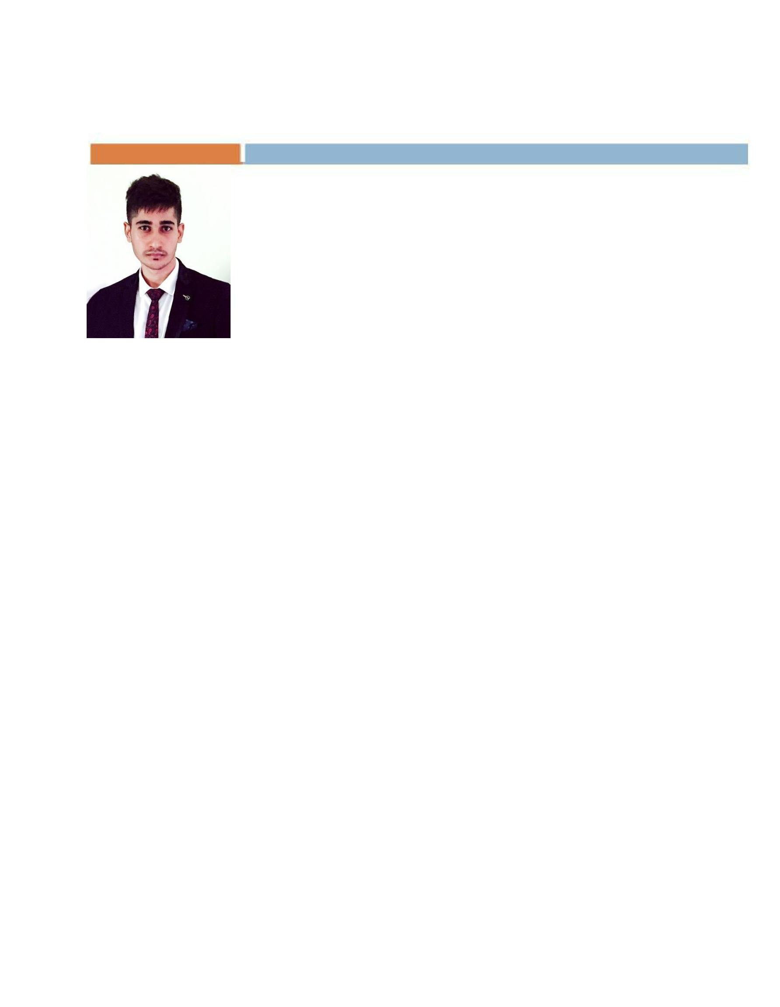
RESUME

Syed

Dubai

U.A.E.

E-mail id: syed.338693@2freemail.com

OBJECTIVES

To work in an organisation wherein I would be able to explore my knowledge to contribute to the growth of the organisation and which would help me develop various skills that would make me a competent professional.

EDUCATION

  - Bachelor in Computer Applications(B.C.A.2012-2015)

- Pre-University College(2010-2012)
Completed 2nd PUC

- School(2010)

SOFTWARE APPLICATIONS

AutoCAD-Computer Aided Design.

TECHNICAL PROFICIENCY

Basics of C Programming, MS Word, MS Excel and MS Power Point.

CAREER HISTORY

Razas Gold Palace-Bangalore,India
Sales Executive, (July 2015-December 2016)

Role:

- Involve in direct sales of the products at the store.

- Have a well required interaction with the customers to know their requirements.

- Communicate with the manager regarding the sales, changes to be made and other important issues.

- Keep a track on the personal and showroom targets and work towards it individually and with the team.

- Ensuring that all the policies and services are well known and updating ourselves with the new products.

- Prepare Cash Sheet and Stock Sheet on daily basis for easy cash flow.

Achievements:

- Achieved the targets.

- High level of customer satisfaction with the best service.

PERSONAL DETAILS

Date OfBirth 25/04/1994

Strengths Face situations in an optimistic manner, Accept given

responsibilities and give my best to it, Dedicated and
Honest, Work effectively under pressure.

Languages English, Hindi, Kannada, Urdu.

Hobbies Surfing internet

VISA Tourist Visa(until

15 march)

