ABHIJITH
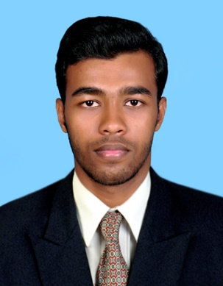
ABHIJITH.338715@2freemail.com

Objective
To be potential resource to the organization where I can utilize all my skills & knowledge which would help the organization to grow & further enhance my growth profile. It would be my never-ending dedication to maintain the spectrum of integrity, honesty and character.

Job Profile

Description : Software/ Web Developer.
Responsibilities: 1. Documenting technical specifications.
2. Writing programming code.
3. Designing the application according to specifications.
4. Coordinating with designers, administrators, and other programmers.
5. Prioritizing tasks and daily activities.
Technical Skills: PHP5, HTML, CSS3, Bootstrap, Jquery, JavaScript, Ajax, MySQL, Angular JS
Experience

Company Name | Designation | From | To
POS Scan Computer Trading | Technical Support | Aug 20th 2016 | Present
LogikAvenue IT Solutions | Software Engineer | Sep 9th 2015 | May 31st 2016
Leopards Media | Software Engineer | April 5th 2014 | July 30th 2015

Projects

1. Web Application for checking IIS Logs and Geo Location
Technologies Used: PHP, MySQL, HTML, CSS3, JavaScript, Windows Task Scheduler.
Description: Created a web application to read the IIS logs and split the data into respective fields and enter the data in to the MySQL database. Along with that, Geo location is also activated thus can track each user using his/her IP. The code for reading the data from IIS log and write those data to database are run periodically by using Windows Task Scheduler.
2. Website for Real Estate
Technologies Used: PHP, MySQL, HTML, Bootstrap, CSS3, Ajax, JavaScript, JQuery.
Description: Developing a website for real estate with lot of functionalities.
3. Web Application for Customer Management.
Technologies Used: PHP, MySQL, JQuery, HTML, CSS3, Ajax, JavaScript.
Description: A very much user friendly customer management system for a home delivery food organization with an admin panel.

Academic Qualifications

Qualification | School/College/  Institution | Name of Board/University | Specialization or Subjects | Year of passing | Total marks  %
BTECH | School of Engineering | Cochin University of Science and Technology | INFORMATION TECHNOLOGY | 2014 | 61
XII | Vivekananda Higher Secondary School | STATE | PCMB | 2009 | 80
X | Vivekananda Higher Secondary School | STATE |  | 2007 | 85

Achievements
- Got first Place in university Athletic meet in the year 2013 and 2014
- College sports captain
- College Department Association President
- Participated in State Level Quiz competition
- Got First prize in photography competition in college
- Organize college Technical Fest
Personal details
Date of Birth : 08-12-1990

Marital Status : Single
Nationality : Indian
Languages known : English, Malayalam and Tamil

Declaration

I hereby declare that all the statements made above are correct.

Place: Dubai
Date: 10/07/2016

