To

HR/ Personnel Manager,
United Arab Emirates.

Dear Sir/Madam,

I hereby enclose my resume as a first step in exploring the possibilities of employment in your esteem organization. I truly believe that the application of mine creates a positive impact in you that will pave a great privilege in future representing you.

Thanking you in anticipation.

Yours Sincerely,

Fahad

CURRICULUM VITAE
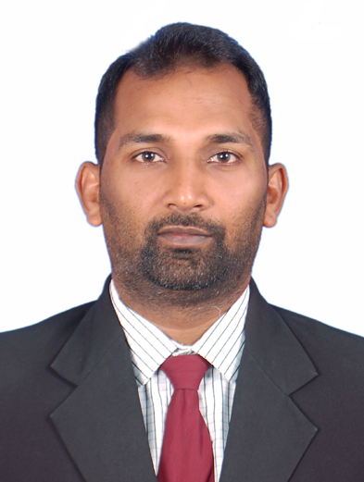

Fahad
Fahad.338739@2freemail.com

Career Objective
- To be associated with a growth oriented organization where my skill can be better utilized toward mutual growth and to utilize my technical and functional capability.
- Looking for a challenging role in an organization where growth and prospects are unlimited with culture of performance based appreciations.
- Looking ahead to work in challenging environment and to strive for excellence and to secure a challenging position in it. This may enable me to integrate my knowledge and skills.
Area of Interest
- Sales & Marketing

Computer Skills

- MS-Office-(ms word, excel, power point, internet)
Profile Summary
- Methodical and responsible person with Distinctive ability to manage and delegate several tasks in a stressful work environment.
- Excellent communicator seeking a challenging position, utilizing current skills and abilities, with the opportunity for professional growth. Strong organizational and interpersonal skills with ability to multitask a variety of responsibilities
SKILLS & EXPERIENCE
1. Organization: LifeCell International PVT LTD. (Mangalore)
Designation : Relationship Executive
Work Experience : September 2013 upto December 2016

JOB DESCRIPTIONS
- Meeting new clients and doctors and explaining the benefits and uses of stem cells
- Ensuring the clients about the safeguard procedure of stem cell
- Responsible for sales and achieving targets.
- Tapping new customers.

2. Organization: Birla SunLife Insurance. (Mangalore)
Designation : Agency Manager
Work Experience : June 2011 upto August 2013

JOB DESCRIPTIONS

- Responsible for Sales of Life Insurance Products.
- Customer Service to the existing customers over products and services.
- Sales planning to achieve targets and prepare monthly sales reports.
- Received training on Products

3. Organization: Skoda Auto. (Tafe Access Limited, Mangalore)
Designation : Sales Consultant
Work Experience : June 2008 up to June 2011

JOB DESCRIPTIONS
- Devises sales strategies and promotions to obtain maximum sales volume.
- Directs all sales personnel. Directs preparation of reports.
- Formulates and recommends policies and programs.
- Interprets and enforces company policy and practices Ensures the adequacy of training programs

4. Organization: Barclays Bank. (Abu Dhabi)
Designation : Sales Officer
Work Experience : December 2006 up to March 2008

JOB DESCRIPTIONS
- Responsible for Sales of Credit Cards.
- Customer Service to the existing customers over products and services.
- Analyzed financial documents to determine customers credit worthiness.
- Sales planning to achieve targets.
- Prepare monthly sales reports.
- Received training on cards

5. Organization: ICICI Bank. (Mangalore)
Designation : Senior Sales Officer
Work Experience : December 2004 up to May 2006

JOB DESCRIPTIONS
- Determine customer financial services needs and prepare proposal to sell savings a/c, FD a/c, RD a/c & student's a/c.
- Display exemplary behavior by maintaining up-to-date knowledge of banking products and be role model for other.
- Developed and maintained positive and professional relationship with corporate / individual clients.

Education Qualification

- Completed intermediate from Mangalore University in 2003.
- S.S.L.C passed from Board of Secondary in 2001.
- Diploma In computer hardware and networking

Co-Curricular Activities

- Playing Cricket, Listing to Music, Snookers and Making Friends

Strengths

Good Team Player

Quick learner and result oriented

Hardworking, energetic and dedicated

Always looking forward to accept new challenges

Languages Known
English, Hindi, Urdu & Kannada.

Personal Details
Date of Birth : 02nd Jan 1984
Gender : Male
Marital Status : Single
Nationality : Indian
Visa Status : Visit Visa

Declaration

I declare that the above information is true and correct to the best of my knowledge and nothing has been concealed or distorted.

