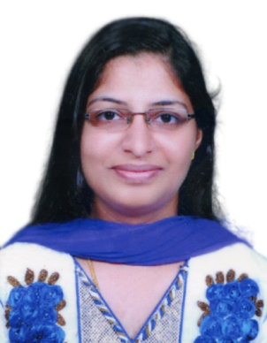
Divya, Registered Nurse
Divya.338763@2freemail.com
Abu Dhabi, UAE

Objective

Seeking a challenging position in a reputed hospital where my extensive medical professional and practical experience will be fully utilized. Compassionate Nursing Professional seeking opportunity requiring exceptional organizational skills and talents in patient relation, education and advocacy; can offer outstanding abilities in assessment, formulating diagnoses, establishing goals, implementing intervention and evaluating outcomes.

Education

BACHELOR OF SCIENCE IN NURSING, Malik Deenar College of
Nursing, Kannur University, Kasaragod, Kerala, India, November 2007.

Career Profile

- Proven record of reliability and responsibility.
- Remain calm and professional throughout critical incidents.
- Strong analytical skills, capable of assessing conditions and implementing appropriate intervention.
- Resourceful problem solver, capable of implementing solutions to complex problems.
- Possess special sensitivity to meeting diverse needs in varied situations.
- Develop rapport with patients, family staff and physicians.

HAAD Licensure Examination for Registered Nurse , passed on 19th November 2010. HAAD issued my RN License on July 2011.
License No:, expiring on December 2018.

Passed Basic Life Support, ACLS AND NRP course conducted by AMERICAN HEART ASSOSSIATION .

Professional Experience

- Working as a Registered Nurse in since October 2014 in medical surgical ward.

- Worked as a Registered Nurse and also a shift in charge in LLH Hospital (life line)(JCI Accredited), mussafah, Abu Dhabi UAE, from 6th August 2011 to 21st September 2014, in medical surgical ward.

- Worked as a Staff Nurse, Ananthapuri Hospitals and Research Institute, Trivandrum, Kerala, India, June 2008 – December 2010 ,my experience was in post anesthesia care unit.

Provided, Coordinated, and documented care for patients; maintained communication among care staff; documented and inputted patient care data in computer and served as liaison between patient and doctor.

- Implement patient care for up to 12 patients per section.
- Scheduled patient admissions and discharges.
- Asses patient status and notify physicians of clinical changes.
- Interact with departments regarding patient care.
- Educate patients/families on health care needs, condition, options etc.
- Maintained patient charts and confidential files.
- Performed clinical tasks according of new staff members.

Personal Details

Age & Date of birth : 30 years, 25th May 1986
Sex : Female
Marital status : Married
Nationality : Indian
Religion : Christian
Languages knows : English, Hindi, Malayalam
:

Excellent references available upon request

Declaration
I hereby declare that the above statements are correct and complete to the best of my knowledge and belief.

Abu Dhabi
Date 30-01-2017

