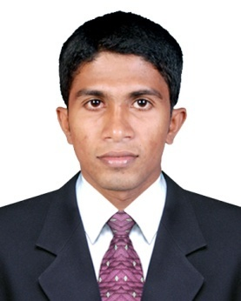
CURRICULUM VITAE

NIYAS
Email : niyas.338768@2freemail.com

OBJECTIVES

To pursue my excellence with hard work, dedication and self-determination in order to interact with the best of my professional approach towards my career path and job assignments.
PROFFESIONAL SUMMARY

- Bachelore of Computer Application
- IATA - Travel and Tourism Consultant ( Montreal )
ACADEMIC QUALIFICATION

- IATA - Travel and Tourism Consultant course (2015 December) from Akbar Academy,Chavakkad.
- Bachelor of Computer Application (2009-2012) from Mother Arts & Science College Affiliated to Calicut University.
- Higher Secondary Education (2007-2009) from Board of Higher Secondary Examination at I C A, Vattampadam.
- Secondary School Education (2007) from R E H S, Thozhiyur.
- Cisco Certified Network Associate (CCNA)
- Microsoft Certified IT Profession (MCITP)
- Diploma in Computer Hardware
SOFTWARE SKILL

- Travelport (Galileo) SmartPoint & FocalPoint
- Amadeus Selling platform
- Office Program (Microsoft Office)
- Internet

WORK EXPERIENCE

Company : World air Tours & Travels
Designation : Travel Consultant
Period : December 2015 to January 2017

Company : Pearson Education Services Pvt Ltd,Bangalore
Designation : Resource Coordinator Period : May 2014 to June 2015

Company : Esquire Computers
Designation : Service Engineer
Period : January 2013 to February 2014

DUTIES AND RESPONSIBILITIES

- Handling ticketing and reservation for customers and agents
- Liaising with clients in person,over the phone or via email to discuss their travel requirements
- Diagnosing client’s specifications and wishes,suggesting suitable travel packages
- Advising clients on suitable options for domestic or international destinations
- Give advise about local weather conditions,customs and attractions
- Organizing travels from beginning to end including tickets,insurance,food,accommodation and transportation
- Preparing customised itineraries to suite the client’s preferences and budget
- Researching destinations and keeping up to date with travel industry news
- Providing relevant information,brochures and publications ( guides,local customs,maps,regulation,events ) to travelers
- Carry out all follow up procedures pertaining to customer travels, that is reconfirmation of airline tickets and tours
- Modifying existing bookings to suit a change in client’s circumstances
- Knowledge in Airline fare rule,BSP payments,Ticket cancellation and refunds
- Fix appointment for passport to customers
- Telephones customer or Ticket Agents to advise of changes with travel conveyance or to confirm reservation.
- Providing feedback after a tour as part of a debrief session

PERSONAL DETAILS

Name : NIYAS
Gender : MALE
Date of Birth : 06 OCTOBER 1990
Marital status : Single
Language Known : English, Malayalam, Tamil
Visa Status : Visit Visa

DECLARATION

I hereby declare that the information furnished above is true to the best of my knowledge. Iam also confident of my ability to work in a team.
Yours truly,
Niyas

