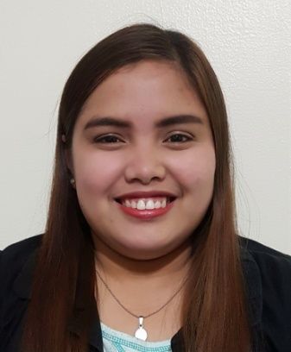
APRIL
APRIL.338783@2freemail.com

OBJECTIVE

To work for a company that offers professional development and growth potential as well as to further build upon my previous trainings and work experiences.

SKILLS

- Ability to work with little or no supervision, competent, strong team-player, attention to detail and with excellent prioritizing and organizational skills.
- Ability to handle all situations with compassion and professionalism, critical thinking, and clear vision to accomplish company goals.

EDUCATION

2009 – 2013 La Salle University- Ozamiz City
Bachelor of Science in Office Administration

WORK EXPERIENCE

February 14, 2014 – November 20, 2016 MLhuillier Financial Services
Lanao Region, Philippines
Assistant Branch Manager

- Money Transfer and Money Exchange Operator
- Gold Appraiser
- Answering telephone calls professionally.
- Anticipating and meeting the needs of the office.
- Filing reports and ensuring the confidentiality of all documentation and information.
- Resolving administrative queries.

PROFESSIONAL DEVELOPMENT AND TRAINING

June 2016 - Basic Diamond Appraisal Training
Iligan City, Philippines

December 2015 - Corporate Foundation Training
Iligan City, Philippines

August 2014 - Branch Operating System Training
Ozamiz City, Philippines

