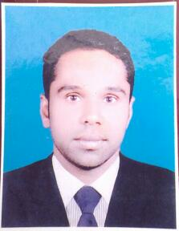 MOHAMED
MOHAMED.338791@2freemail.com

Objective

To be engaged in a company that values, professional growth, career advancement and employees’ dedication to further grow and enhance my career opportunities.

Special Skills / Qualifications

Service orientation excellent communication skills.
Calm and pleasant mind
Hardworking, independent, dedicated and competent
Good relation with everyone

Work experiences

1 Company lord’s hotel
Position front office receptionist
2008 to 2013,, deira Dubai

2 Worked as a receptionist torch tower hotel. In Doha Qatar
From 2015 January

Other

3 Worked as a front desk assistant more than two years
In Trans world agent srilanka

Professional qualification

1 Completed the diploma in computer studies 6month course
(MS Word 2004, excel, access, power point,)

2 Completed the diploma in hotel management
(2years from 2003 to 2005)

Educational qualification

Passed general certificate of examinations advance level conducted by the government of srilanka in august 2002

Subject’s grade

1 political science c
2 Islam C
3 geography C

Known language

(English, Hindi, Tamil, Malayalam, and Sinhala)

Personal Information

Birthdates : June 11, 1983
Birthplace : matale
Civil Status : married
Nationality : srilanka

Visa Status : Visit Visa Expiry Date 03/04/17

Applied for receptionist

