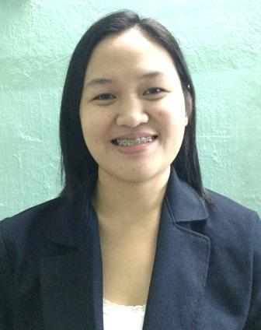

MARIDEL
Maridel.338798@2freemail.com

CAREER OBJECTIVE

Looking forward for dynamic career in an organization where my skills and abilities are utilized for Organization as well as my professional growth.

QUALIFICATION AND SKILLS

- More than 8 years of experience as medical assistant / secretary and Medical Representative.
- Thrives in competitive environment by being aggressive at work.
- Ability to work in group as well as independently with minimal supervision.
- Outstanding interpersonal skills and dynamism to provide excellent customer satisfaction & obtain set goals.
- Fast learner with a desire to learn and grow.
- Efficient knowledge in the use of Microsoft Office & the Internet.

WORK EXPERIENCE
- Medical Receptionist/Asst. Insurance coordinator Jan.2016 up to present
Clinicare Samari Medical Centre (Br. Of Imara Healthcare) Ras Al Khor Industrial Area

- Getting approval for medical procedures.
- Ensuring coverage of claims, guiding staff for correct use of claim forms, approval papers.
- Greetings the patient as well the visitors.
- Explaining coverage of medical benefits to patients when required.
- Assisting invoicing department in insurance processing and billing.
- To network with insurance companies regarding eligibility, payments, approvals, reconciliation and other requirements.
- Receiving calls and ensuring satisfaction of patient/client.
- To design and implement a protocol for insurance practices.
- To maintain and update records related to pre-approvals and reconciliation.
- Performs the duly of a cashier like handling cash and settling of bills payments of patient/client.
- Recording and keeping the files,
- Dealing with referring doctors courteously and helpfully.

- Medical Representative June 2011 to July 2015
Delax Pharma International Inc. Quezon City, Philippines

- Follow up orders specially for those in urgent basis
- Filing delivery notes, invoices by project
- Completes requests by greeting customers, in person or on the telephone; answering or referring inquiries.
- Maintains customer confidence and protects operations by keeping information confidential.
- Produces information by transcribing, formatting, inputting, editing, retrieving, copying, and transmitting text, data, and graphics
- Giving more information about the products and their respective uses.
- Performing utmost best for the customer.
- Bringing quality and cost effective of the products.

- Medical Assistant / Secretary August 2008 to February 2011
Commonwealth Hospital & Medical Center Quezon City, Philippines

- Performs the duly of an assistant during operations in ensuring satisfaction of patient/client by providing excellent service.
- Assists patient/client with their queries or inquiries.
- Performs the duly of a cashier like handling cash and settling of bills and payments of patient/client.
- Prepare / set appointments for patients.

- Receiving calls and ensuring satisfaction of patient/client.
- Recording and keeping the files.
- Answering the telephone promptly and courteously.
- Making appointments for patients following set procedure.
- Dealing with referring doctors courteously and helpfully.

- Dental Receptionist June 2007 to June 2008
The Lapid Dental Center SM The block Quezon City

- Performs the duly as a secretary by assisting the doctors during operation.
- Assisting the customer/patients.
- Answering the telephone promptly and courteously.
- Recording and keeping the files.
- Prefer/set appointments for patients.
- Receiving calls and ensuring satisfaction of customer/patients.

EDUCATIONAL ATTAINMENT

Tertiary Level 2002-2007 Bachelor of Science in Nursing
April 03, 2007 (Date of Graduation)
Dr. Carlos Lanting College
T.Sora, Quezon City, Philippines

PERSONAL INFORMATION

Nationality : Filipino Language : English & Tagalog
Gender : Female Height : 5’3”
Marital Status : Married Weight : 110lbs
Visa Status : Residence Visa

